大数据项目之数仓

版本：V1.0

# 第1章 数仓分层概念

## 1.1 为什么要分层



## 1.2 数仓分层





## 1.3 数据集市与数据仓库概念



## 1.4 数仓命名规范

* ODS层命名为ods
* DWD层命名为dwd
* DWS层命名为dws
* ADS层命名为ads
* 临时表数据库命名为xxx_tmp
* 备份数据数据库命名为xxx_bak

详见：尚硅谷大数据技术之Hive



## 2.1 Hive&MySQL安装

### 2.1.1 Hive&MySQL安装

### 2.1.2 修改hive-site.xml

1）关闭元数据检查

[atguigu@hadoop102 conf]$ pwd

/opt/module/hive/conf

[atguigu@hadoop102 conf]$ vim hive-site.xml

增加如下配置：

<property>

<name>hive.metastore.schema.verification</name>

<value>false</value>

</property>

# 环境准备

jdk1.8 、hadoop-2.7.2、hive、spark2.1.1

# 第3章Spark集群安装

## 集群角色

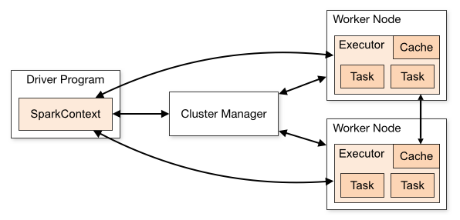

从物理部署层面上来看，Spark主要分为两种类型的节点，Master节点和Worker节点，Master节点主要运行集群管理器的中心化部分，所承载的作用是分配Application到Worker节点，维护Worker节点，Driver，Application的状态。Worker节点负责具体的业务运行。

从Spark程序运行的层面来看，Spark主要分为驱动器节点和执行器节点。

## 机器准备

准备两台以上Linux服务器，安装好JDK1.8

## 下载Spark安装包

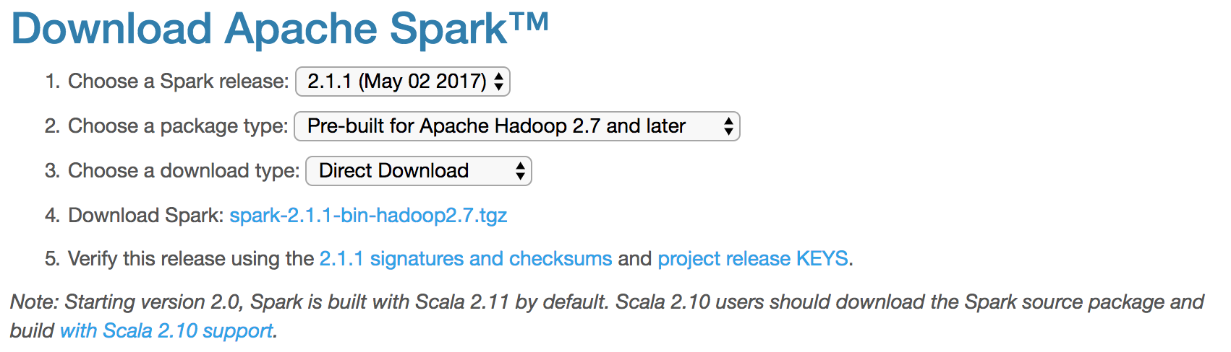

上传解压安装包

上传spark-2.1.1-bin-hadoop2.7.tgz安装包到Linux上

解压安装包到指定位置

tar -xf spark-2.1.1-bin-hadoop2.7.tgz -C /home/bigdata/Hadoop



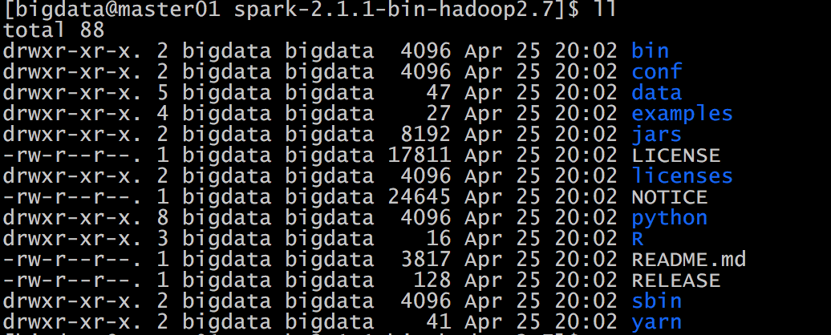

## 配置Spark【Yarn】

修改Hadoop配置下的yarn-site.xml:

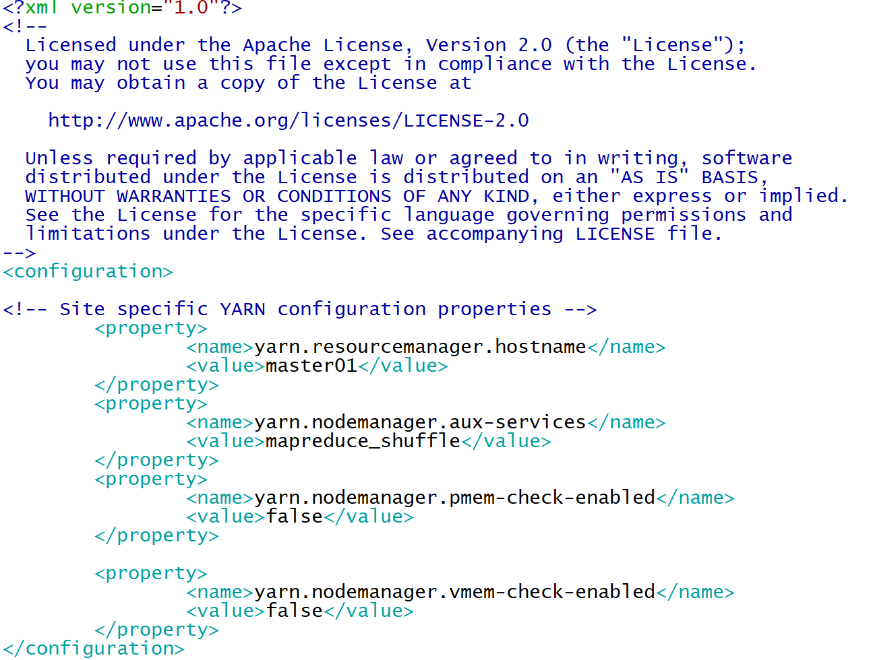

|  |
| --- |
| <configuration>  <!-- Site specific YARN configuration properties -->  <property>  <name>yarn.resourcemanager.hostname</name>  <value>master01</value>  </property>  <property>  <name>yarn.nodemanager.aux-services</name>  <value>mapreduce_shuffle</value>  </property>  <!--是否启动一个线程检查每个任务正使用的物理内存量，如果任务超出分配值，则直接将其杀掉，默认是true -->  <property>  <name>yarn.nodemanager.pmem-check-enabled</name>  <value>false</value>  </property>  <!--是否启动一个线程检查每个任务正使用的虚拟内存量，如果任务超出分配值，则直接将其杀掉，默认是true -->  <property>  <name>yarn.nodemanager.vmem-check-enabled</name>  <value>false</value>  </property>  </configuration> |

修改Spark-env.sh 添加：

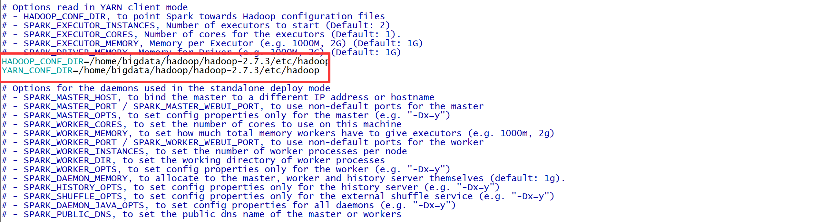

让Spark能够发现Hadoop配置文件

|  |
| --- |
| HADOOP_CONF_DIR=/home/bigdata/hadoop/hadoop-2.7.3/etc/hadoop  YARN_CONF_DIR=/home/bigdata/hadoop/hadoop-2.7.3/etc/hadoop |

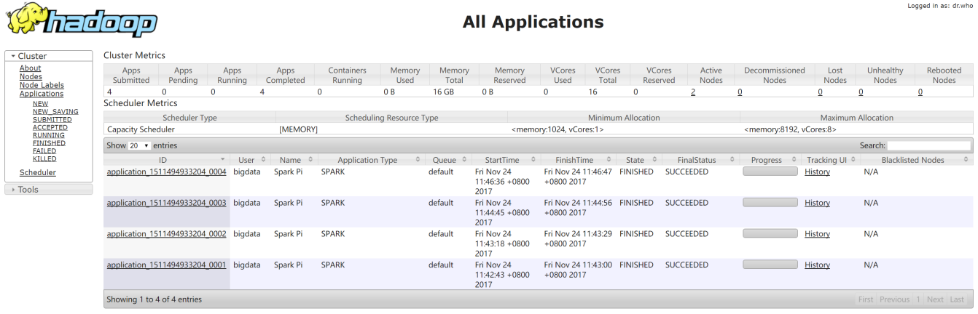

启动spark history server：

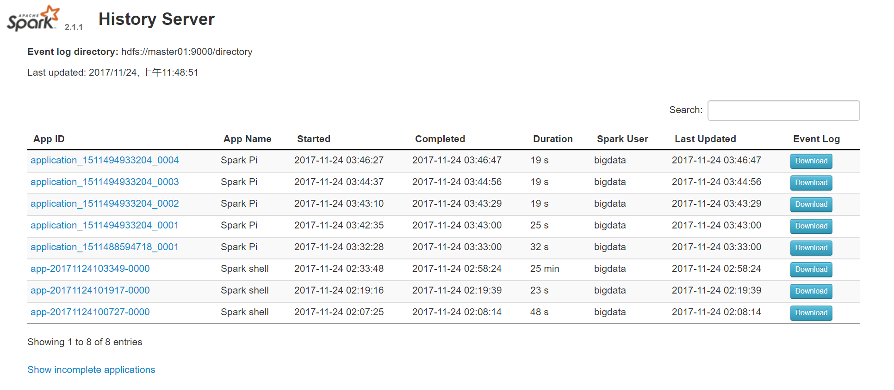

可以查看日志。

## Spark核心概念

每个Spark应用都由一个驱动器程序(driver program)来发起集群上的各种 并行操作。驱动器程序包含应用的 main 函数，并且定义了集群上的分布式数据集，还对这 些分布式数据集应用了相关操作。

驱动器程序通过一个 SparkContext 对象来访问 Spark。这个对象代表对计算集群的一个连 接。shell 启动时已经自动创建了一个 SparkContext 对象，是一个叫作 sc 的变量。

驱动器程序一般要管理多个执行器(executor)节点。

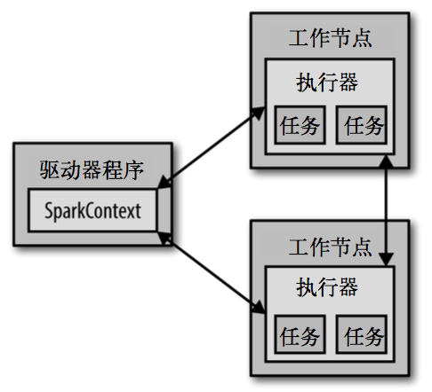

# 第4章 模拟场景 建库建表

项目数仓分为odl层，bdl层，idl层，adl层

odl层对应ods

bdl层对应dwd

idl层对应 dws

adl层对应ads

准备用户基本日志数据、用户注册日志数据、广告基本日志数据、网站基本日志数据、用户支付金额日志数据、vip等级基本日志数据

数据收集到后，需要将原始数据上传到odl层，odl层存储的数据为原始数据。

对odl层进行数据清洗后存入bdl层，针对bdl层清洗的数据做业务之间的聚合，合成宽表和拉链表，基于bdl层宽表数据进行统计分析，将指标数据存入adl层，adl层为报表数据。

odl->bdl->idl->adl

假设我们已经收集到了日志

使用hdfs命令将日志上传到hadoop集群上 hadoop dfs -put xxx.log /user/atguigu/odl/

## 4.1各层级表

1. hive创建三个库 bdl、idl、adl

create database bdl;

create database idl;

create database adl;

1. bdl层表

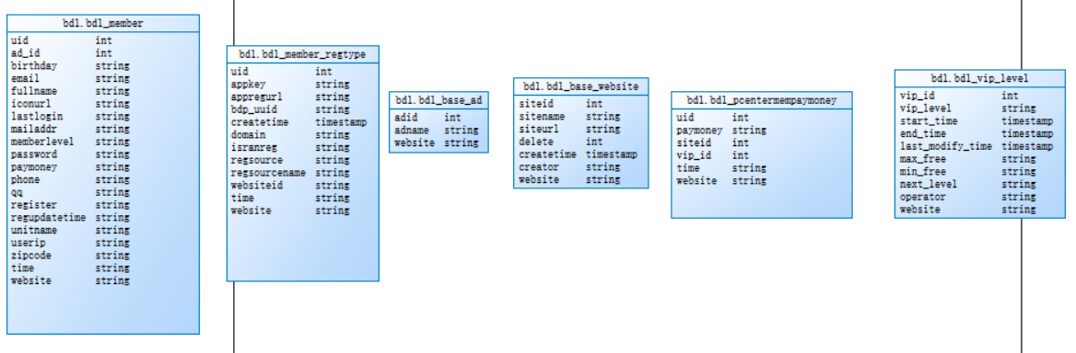

1. idl层表

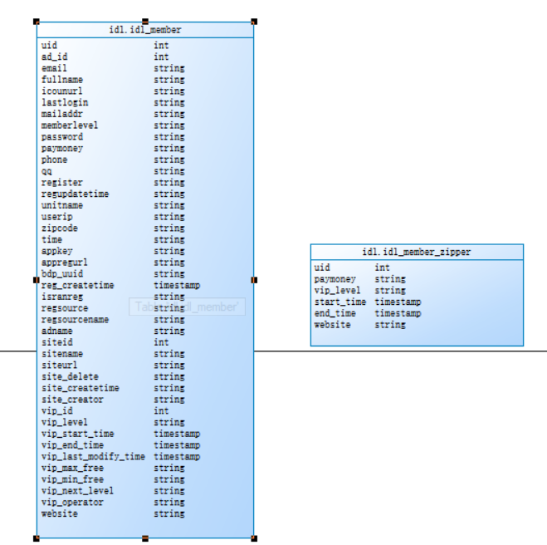

1. adl层表

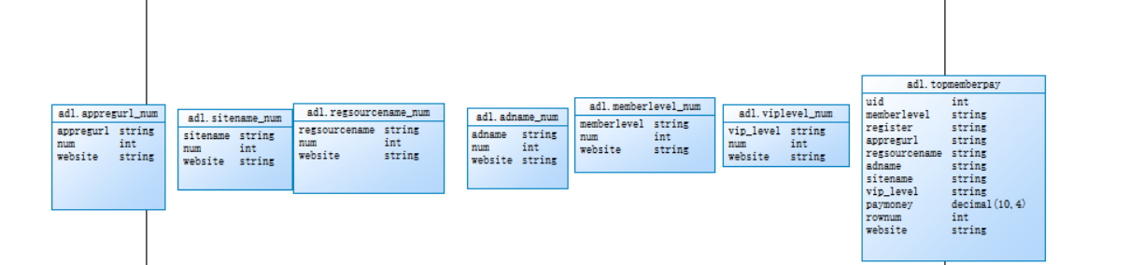

## 4.2建表语句

create external table `bdl`.`bdl_member`(

uid int,

ad_id int,

birthday string,

email string,

fullname string,

iconurl string,

lastlogin string,

mailaddr string,

memberlevel string,

password string,

paymoney string,

phone string,

qq string,

register string,

regupdatetime string,

unitname string,

userip string,

zipcode string)

partitioned by(

time string,

website string

)

ROW FORMAT DELIMITED

FIELDS TERMINATED BY '\t'

STORED AS PARQUET TBLPROPERTIES('parquet.compression'='SNAPPY');

create external table `bdl`.`bdl_member_regtype`(

uid int,

appkey string,

appregurl string,

bdp_uuid string,

createtime timestamp,

domain string,

isranreg string,

regsource string,

regsourcename string,

websiteid int)

partitioned by(

time string,

website string)

ROW FORMAT DELIMITED

FIELDS TERMINATED BY '\t'

STORED AS PARQUET TBLPROPERTIES('parquet.compression'='SNAPPY');

create external table `bdl`.`bdl_base_ad`(

adid int,

adname string)

partitioned by (

website string)

ROW FORMAT DELIMITED

FIELDS TERMINATED BY '\t'

STORED AS PARQUET TBLPROPERTIES('parquet.compression'='SNAPPY');

create external table `bdl`.`bdl_base_website`(

siteid int,

sitename string,

siteurl string,

`delete` int,

createtime timestamp,

creator string)

partitioned by (

website string)

ROW FORMAT DELIMITED

FIELDS TERMINATED BY '\t'

STORED AS PARQUET TBLPROPERTIES('parquet.compression'='SNAPPY');

create external table `bdl`.`bdl_member_wxbound`(

uid int,

unionid string,

openid string,

nickname string,

isdefault string,

headimgurl string,

boundtime timestamp,

bindsource int

)

partitioned by (

time string,

website string)

ROW FORMAT DELIMITED

FIELDS TERMINATED BY '\t'

STORED AS PARQUET TBLPROPERTIES('parquet.compression'='SNAPPY');

create external table `bdl`.`bdl_wxtype`(

bind_source int,

app_id string,

token_secret string,

wx_name string,

wx_no string,

createtor string,

createtime string

)partitioned by(

website string

)

ROW FORMAT DELIMITED

FIELDS TERMINATED BY '\t'

STORED AS PARQUET TBLPROPERTIES('parquet.compression'='SNAPPY');

create external table `bdl`.`bdl_pcentermempaymoney`(

uid int,

paymoney string,

siteid int,

vip_id int

)

partitioned by(

time string,

website string

)

ROW FORMAT DELIMITED

FIELDS TERMINATED BY '\t'

STORED AS PARQUET TBLPROPERTIES('parquet.compression'='SNAPPY');

create external table `bdl`.`bdl_vip_level`(

vip_id int,

vip_level string,

start_time timestamp,

end_time timestamp,

last_modify_time timestamp,

max_free string,

min_free string,

next_level string,

operator string

)partitioned by(

website string

)

ROW FORMAT DELIMITED

FIELDS TERMINATED BY '\t'

STORED AS PARQUET TBLPROPERTIES('parquet.compression'='SNAPPY');

create external table `idl`.`idl_member`(

uid int,

ad_id int,

fullname string,

iconurl string,

lastlogin string,

mailaddr string,

memberlevel string,

password string,

paymoney string,

phone string,

qq string,

register string,

regupdatetime string,

unitname string,

userip string,

zipcode string,

time string,

appkey string,

appregurl string,

bdp_uuid string,

reg_createtime timestamp,

domain string,

isranreg string,

regsource string,

regsourcename string,

adname string,

siteid int,

sitename string,

siteurl string,

site_delete string,

site_createtime string,

site_creator string,

vip_id int,

vip_level string,

vip_start_time timestamp,

vip_end_time timestamp,

vip_last_modify_time timestamp,

vip_max_free string,

vip_min_free string,

vip_next_level string,

vip_operator string

)partitioned by(

website string

)

ROW FORMAT DELIMITED

FIELDS TERMINATED BY '\t'

STORED AS PARQUET TBLPROPERTIES('parquet.compression'='SNAPPY');

create external table `idl`.`idl_member_zipper`(

uid int,

paymoney string,

vip_level string,

start_time timestamp,

end_time timestamp

)partitioned by(

website string

)

ROW FORMAT DELIMITED

FIELDS TERMINATED BY '\t'

STORED AS PARQUET TBLPROPERTIES('parquet.compression'='SNAPPY');

create external table `adl`.`appregurl_num`(

appregurl string,

num int

)partitioned by(

website string

)

ROW FORMAT DELIMITED

FIELDS TERMINATED BY '\t'

STORED AS PARQUET TBLPROPERTIES('parquet.compression'='SNAPPY');

create external table `adl`.`sitename_num`(

sitename string,

num int

)partitioned by(

website string

)

ROW FORMAT DELIMITED

FIELDS TERMINATED BY '\t'

STORED AS PARQUET TBLPROPERTIES('parquet.compression'='SNAPPY');

create external table `adl`.`regsourcename_num`(

regsourcename string,

num int

)partitioned by(

website string

) ROW FORMAT DELIMITED

FIELDS TERMINATED BY '\t'

STORED AS PARQUET TBLPROPERTIES('parquet.compression'='SNAPPY');

create external table `adl`.`adname_num`(

adname string,

num int

)partitioned by(

website string

)ROW FORMAT DELIMITED

FIELDS TERMINATED BY '\t'

STORED AS PARQUET TBLPROPERTIES('parquet.compression'='SNAPPY');

create external table `adl`.`memberlevel_num`(

memberlevel string,

num int

)partitioned by(

website string

)ROW FORMAT DELIMITED

FIELDS TERMINATED BY '\t'

STORED AS PARQUET TBLPROPERTIES('parquet.compression'='SNAPPY');

create external table `adl`.`viplevel_num`(

vip_level string,

num int

)partitioned by(

website string

)ROW FORMAT DELIMITED

FIELDS TERMINATED BY '\t'

STORED AS PARQUET TBLPROPERTIES('parquet.compression'='SNAPPY');

create external table `adl`.`topmemberpay`(

uid int,

memberlevel string,

register string,

appregurl string,

regsourcename string,

adname string,

sitename string,

vip_level string,

paymoney decimal(10,4),

rownum int

)partitioned by(

website string

)ROW FORMAT DELIMITED

FIELDS TERMINATED BY '\t'

STORED AS PARQUET TBLPROPERTIES('parquet.compression'='SNAPPY');

## 4.3原始数据格式

1.baseadlog 广告基础表原始json数据

{

"adid": "0",

"adname": "注册弹窗广告0",

"dn": "webA"

}

1. basewebsitelog 网站基础表原始json数据

{

"createtime": "2000-01-01",

"creator": "admin",

"delete": "0",

"dn": "webC",

"siteid": "2",

"sitename": "114",

"siteurl": "www.114.com/webC"

}

1. basememberregtypelog 用户跳转地址注册表

{

"createtime": "2000-01-01",

"creator": "admin",

"delete": "0",

"dn": "webC",

"siteid": "2",

"sitename": "114",

"siteurl": "www.114.com/webC"

}

1. pcentermempaymoneylog 用户支付金额表

{

"dn": "webA",

"paymoney": "162.54",

"siteid": "1",

"uid": "4376695",

"vip_id": "0"

}

1. pcentermemviplevellog用户vip等级基础表

{

"discountval": "-",

"dn": "webA",

"end_time": "2019-01-01",

"last_modify_time": "2019-01-01",

"max_free": "-",

"min_free": "-",

"next_level": "-",

"operator": "update",

"start_time": "2015-02-07",

"vip_id": "2",

"vip_level": "银卡"

}

1. memberlog 用户基本信息表

{

"ad_id": "0",

"birthday": "1981-08-14",

"dn": "webA",

"email": "test@126.com",

"fullname": "王69239",

"iconurl": "-",

"lastlogin": "-",

"mailaddr": "-",

"memberlevel": "6",

"password": "123456",

"paymoney": "-",

"phone": "13711235451",

"qq": "10000",

"register": "2016-08-15",

"regupdatetime": "-",

"uid": "69239",

"unitname": "-",

"userip": "123.235.75.48",

"zipcode": "-"

}

## 4.4字段含义

uid:用户id ad_id:广告id fullname:用户名称

memberlevel：用户等级 appregurl:注册跳转地址

regsource:所属平台id regsourcename：所属平台名称

ad_id:广告id adname:广告名称

siteid:网站id sitename:网站名称

paymoney :支付金额

vip_id：vip等级 vip_level:vip等级名称

time 时间（分区字段） website 网站（分区字段 对应json里dn字段）

未标明字段为非统计字段 用默认值或随机字符串即可

# 第5章 流程图

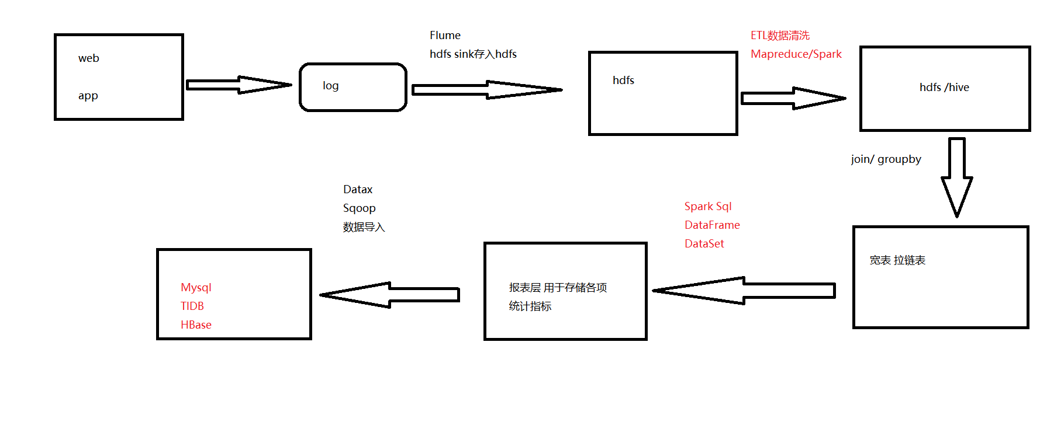

## 5.1整体流程步骤

BdlMemberController->调用EtlDataService方法->进行对hdfs日志数据清洗插入到bdl层各表中。

IdlMemberController->调用IdlMemberService方法->调用BdlMemberDao的sql方法查询各表数据->在service层基于各基础表数据进行join合并成宽表和拉链表。

AdlMemberController->调用AdlMemberService方法->调用IdlMemberDao的sql方法查询宽表数据->在service层基于宽表数据进行报表统计导入到adl层报表对应的hive表。

# 第6章 创建maven 项目

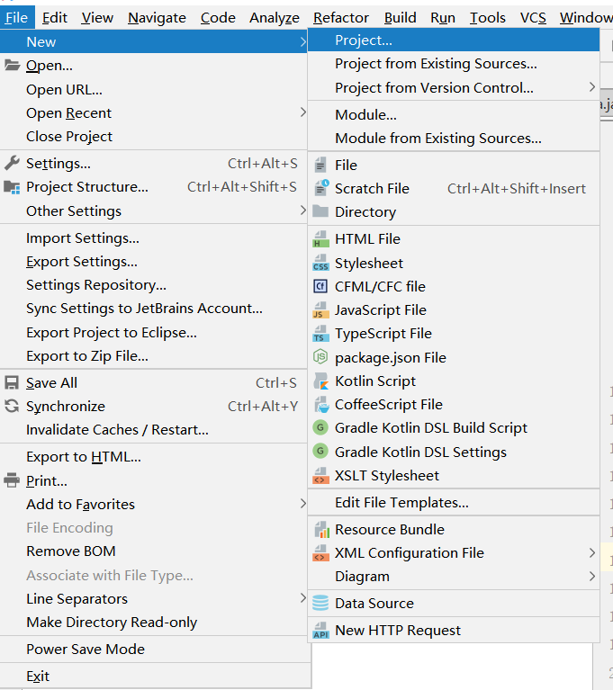

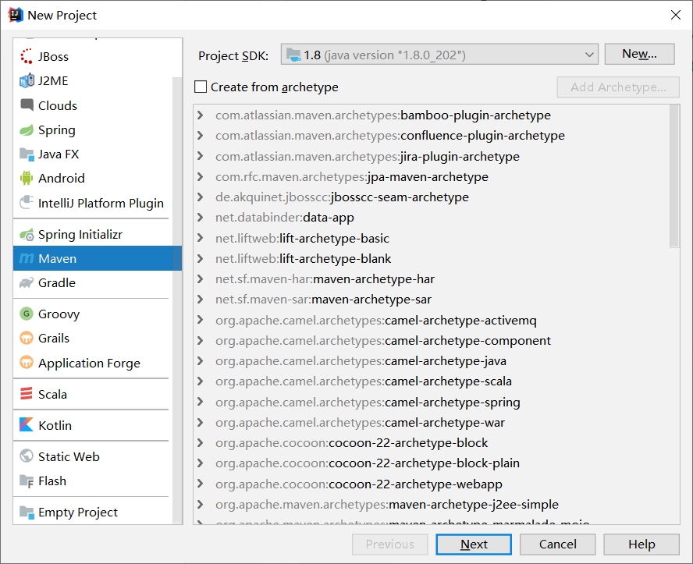

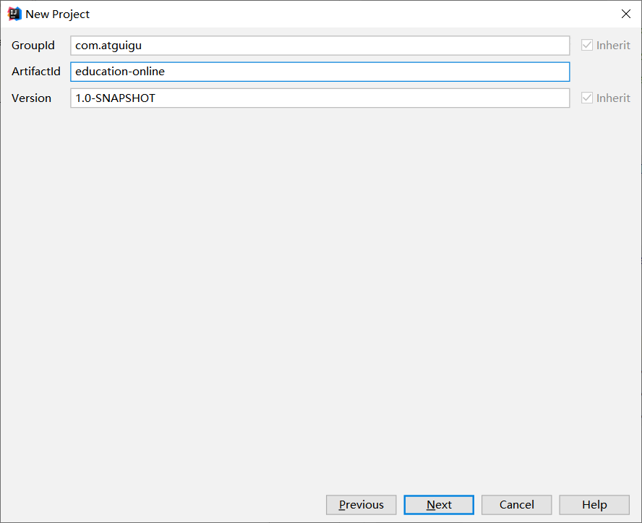

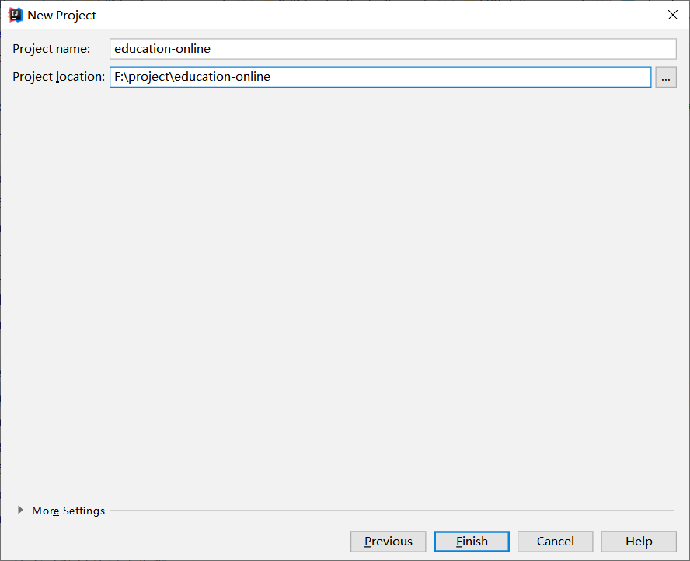

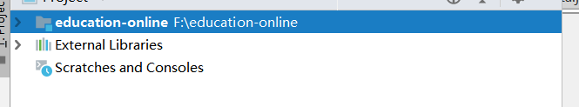

创建子项目

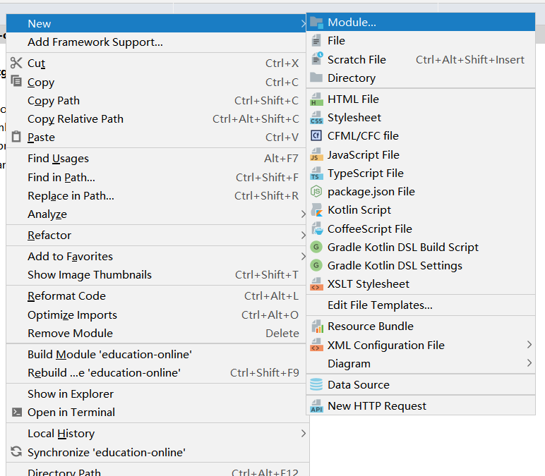

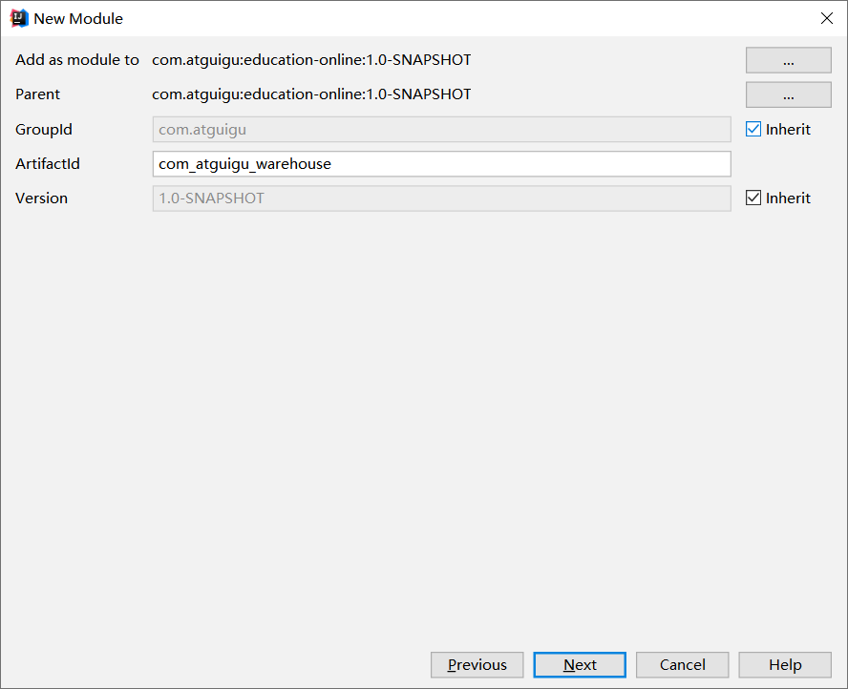

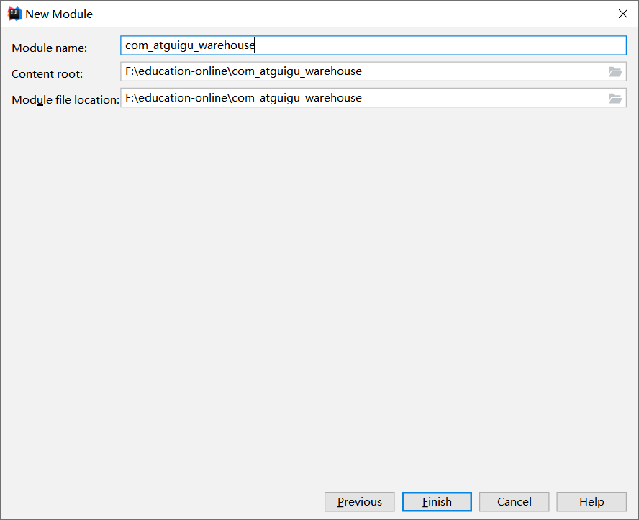

配置主目录pom.xml

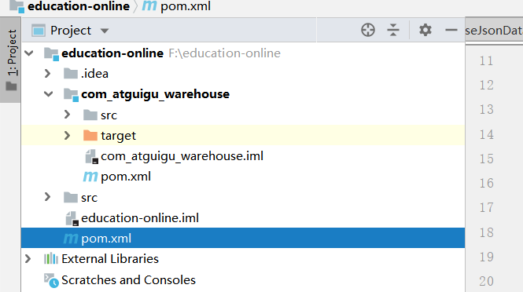

*<?***xml version="1.0" encoding="UTF-8"***?>*<**project xmlns="http://maven.apache.org/POM/4.0.0"  
 xmlns:xsi="http://www.w3.org/2001/XMLSchema-instance"  
 xsi:schemaLocation="http://maven.apache.org/POM/4.0.0 http://maven.apache.org/xsd/maven-4.0.0.xsd"**>  
 <**modelVersion**>4.0.0</**modelVersion**>  
  
 <**groupId**>com.atguigu</**groupId**>  
 <**artifactId**>education-online</**artifactId**>  
 <**packaging**>pom</**packaging**>  
 <**version**>1.0-SNAPSHOT</**version**>  
 <**modules**>  
 <**module**>com_atguigu_warehouse</**module**>  
 </**modules**>  
  
 <**properties**>  
 <**spark.version**>2.1.1</**spark.version**>  
 <**scala.version**>2.11.8</**scala.version**>  
 <**log4j.version**>1.2.17</**log4j.version**>  
 <**slf4j.version**>1.7.22</**slf4j.version**>  
 </**properties**>  
 <**dependencies**>  
  
 *<!-- 所有子项目的日志框架 -->* <**dependency**>  
 <**groupId**>org.slf4j</**groupId**>  
 <**artifactId**>jcl-over-slf4j</**artifactId**>  
 <**version**>${slf4j.version}</**version**>  
 </**dependency**>  
 <**dependency**>  
 <**groupId**>org.slf4j</**groupId**>  
 <**artifactId**>slf4j-api</**artifactId**>  
 <**version**>${slf4j.version}</**version**>  
 </**dependency**>  
 <**dependency**>  
 <**groupId**>org.slf4j</**groupId**>  
 <**artifactId**>slf4j-log4j12</**artifactId**>  
 <**version**>${slf4j.version}</**version**>  
 </**dependency**>  
 *<!-- 具体的日志实现 -->* <**dependency**>  
 <**groupId**>log4j</**groupId**>  
 <**artifactId**>log4j</**artifactId**>  
 <**version**>${log4j.version}</**version**>  
 </**dependency**>  
 *<!-- Logging End -->* </**dependencies**>  
  
 <**dependencyManagement**>  
 <**dependencies**>  
 *<!-- 引入Spark相关的Jar包 -->* <**dependency**>  
 <**groupId**>org.apache.spark</**groupId**>  
 <**artifactId**>spark-core_2.11</**artifactId**>  
 <**version**>${spark.version}</**version**>  
 *<!-- provider如果存在，那么运行时该Jar包不存在，也不会打包到最终的发布版本中，只是编译器有效 -->* </**dependency**>  
 <**dependency**>  
 <**groupId**>org.apache.spark</**groupId**>  
 <**artifactId**>spark-sql_2.11</**artifactId**>  
 <**version**>${spark.version}</**version**>  
 </**dependency**>  
 <**dependency**>  
 <**groupId**>org.apache.spark</**groupId**>  
 <**artifactId**>spark-streaming_2.11</**artifactId**>  
 <**version**>${spark.version}</**version**>  
 </**dependency**>  
 *<!--<dependency>-->  
 <!--<groupId>org.apache.spark</groupId>-->  
 <!--<artifactId>spark-mllib_2.11</artifactId>-->  
 <!--<version>${spark.version}</version>-->  
 <!--</dependency>-->  
 <!--<dependency>-->  
 <!--<groupId>org.apache.spark</groupId>-->  
 <!--<artifactId>spark-graphx_2.11</artifactId>-->  
 <!--<version>${spark.version}</version>-->  
 <!--</dependency>-->* <**dependency**>  
 <**groupId**>org.scala-lang</**groupId**>  
 <**artifactId**>scala-library</**artifactId**>  
 <**version**>${scala.version}</**version**>  
 </**dependency**>  
 <**dependency**>  
 <**groupId**>org.apache.spark</**groupId**>  
 <**artifactId**>spark-hive_2.11</**artifactId**>  
 <**version**>${spark.version}</**version**>  
 </**dependency**>  
  
 </**dependencies**>  
 </**dependencyManagement**>  
  
 *<!-- 声明构建信息 -->* <**build**>  
 *<!-- 声明并引入子项目共有的插件【插件就是附着到Maven各个声明周期的具体实现】 -->* <**plugins**>  
 <**plugin** >  
 <**groupId**>org.apache.maven.plugins</**groupId**>  
 <**artifactId**>maven-compiler-plugin</**artifactId**>  
 <**version**>3.6.1</**version**>  
 *<!-- 所有的编译都依照JDK1.8来搞 -->* <**configuration**>  
 <**source**>1.8</**source**>  
 <**target**>1.8</**target**>  
 </**configuration**>  
 </**plugin**>  
 </**plugins**>  
  
 *<!-- 仅声明子项目共有的插件，如果子项目需要此插件，那么子项目需要声明 -->* <**pluginManagement**>  
 <**plugins**>  
 *<!-- 该插件用于将Scala代码编译成class文件 -->* <**plugin**>  
 <**groupId**>net.alchim31.maven</**groupId**>  
 <**artifactId**>scala-maven-plugin</**artifactId**>  
 <**version**>3.2.2</**version**>  
 <**executions**>  
 <**execution**>  
 *<!-- 声明绑定到maven的compile阶段 -->* <**goals**>  
 <**goal**>compile</**goal**>  
 <**goal**>testCompile</**goal**>  
 </**goals**>  
 </**execution**>  
 </**executions**>  
 </**plugin**>  
  
 *<!-- 用于项目的打包插件 -->* <**plugin**>  
 <**groupId**>org.apache.maven.plugins</**groupId**>  
 <**artifactId**>maven-assembly-plugin</**artifactId**>  
 <**version**>3.0.0</**version**>  
 <**executions**>  
 <**execution**>  
 <**id**>make-assembly</**id**>  
 <**phase**>package</**phase**>  
 <**goals**>  
 <**goal**>single</**goal**>  
 </**goals**>  
 </**execution**>  
 </**executions**>  
 </**plugin**>  
 </**plugins**>  
 </**pluginManagement**>  
  
 </**build**>  
</**project**>

配置子项目pom.xml

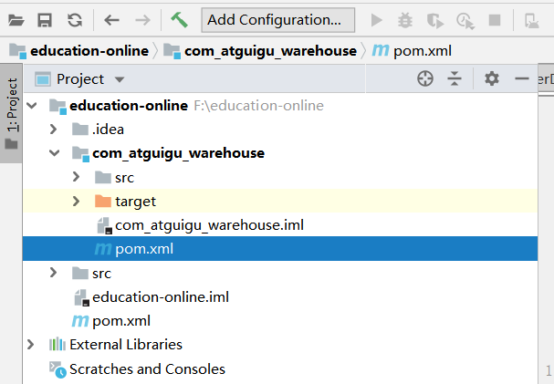

*<?***xml version="1.0" encoding="UTF-8"***?>*<**project xmlns="http://maven.apache.org/POM/4.0.0"  
 xmlns:xsi="http://www.w3.org/2001/XMLSchema-instance"  
 xsi:schemaLocation="http://maven.apache.org/POM/4.0.0 http://maven.apache.org/xsd/maven-4.0.0.xsd"**>  
 <**parent**>  
 <**artifactId**>education-online</**artifactId**>  
 <**groupId**>com.atguigu</**groupId**>  
 <**version**>1.0-SNAPSHOT</**version**>  
 </**parent**>  
 <**modelVersion**>4.0.0</**modelVersion**>  
  
 <**artifactId**>com_atguigu_warehouse</**artifactId**>  
 <**dependencies**>  
 *<!-- Spark的依赖引入 -->* <**dependency**>  
 <**groupId**>org.apache.spark</**groupId**>  
 <**artifactId**>spark-core_2.11</**artifactId**>  
 <**version**>${spark.version}</**version**>  
 <**scope**>provided</**scope**>  
 </**dependency**>  
 <**dependency**>  
 <**groupId**>org.apache.spark</**groupId**>  
 <**artifactId**>spark-sql_2.11</**artifactId**>  
 <**version**>${spark.version}</**version**>  
 <**scope**>provided</**scope**>  
 </**dependency**>  
 <**dependency**>  
 <**groupId**>org.apache.spark</**groupId**>  
 <**artifactId**>spark-hive_2.11</**artifactId**>  
 <**version**>${spark.version}</**version**>  
 <**scope**>provided</**scope**>  
 </**dependency**>  
 *<!-- 引入Scala -->* <**dependency**>  
 <**groupId**>org.scala-lang</**groupId**>  
 <**artifactId**>scala-library</**artifactId**>  
 <**scope**>provided</**scope**>  
 </**dependency**>  
  
 <**dependency**>  
 <**groupId**>com.alibaba</**groupId**>  
 <**artifactId**>fastjson</**artifactId**>  
 <**version**>1.2.47</**version**>  
 </**dependency**>  
 </**dependencies**>  
  
 <**build**>  
 <**plugins**>  
 <**plugin**>  
 <**groupId**>org.scala-tools</**groupId**>  
 <**artifactId**>maven-scala-plugin</**artifactId**>  
 <**version**>2.15.1</**version**>  
 <**executions**>  
 <**execution**>  
 <**id**>compile-scala</**id**>  
 <**goals**>  
 <**goal**>add-source</**goal**>  
 <**goal**>compile</**goal**>  
 </**goals**>  
 </**execution**>  
 <**execution**>  
 <**id**>test-compile-scala</**id**>  
 <**goals**>  
 <**goal**>add-source</**goal**>  
 <**goal**>testCompile</**goal**>  
 </**goals**>  
 </**execution**>  
 </**executions**>  
 </**plugin**>  
 <**plugin**>  
 <**groupId**>org.apache.maven.plugins</**groupId**>  
 <**artifactId**>maven-assembly-plugin</**artifactId**>  
 <**configuration**>  
 <**archive**>  
 <**manifest**>  
 </**manifest**>  
 </**archive**>  
 <**descriptorRefs**>  
 <**descriptorRef**>jar-with-dependencies</**descriptorRef**>  
 </**descriptorRefs**>  
 </**configuration**>  
 </**plugin**>  
 </**plugins**>  
 </**build**>  
  
</**project**>

建相应的项目包

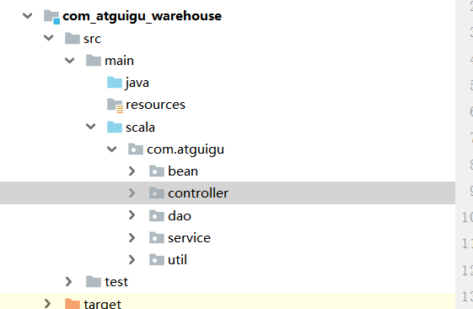

添加scala库支持

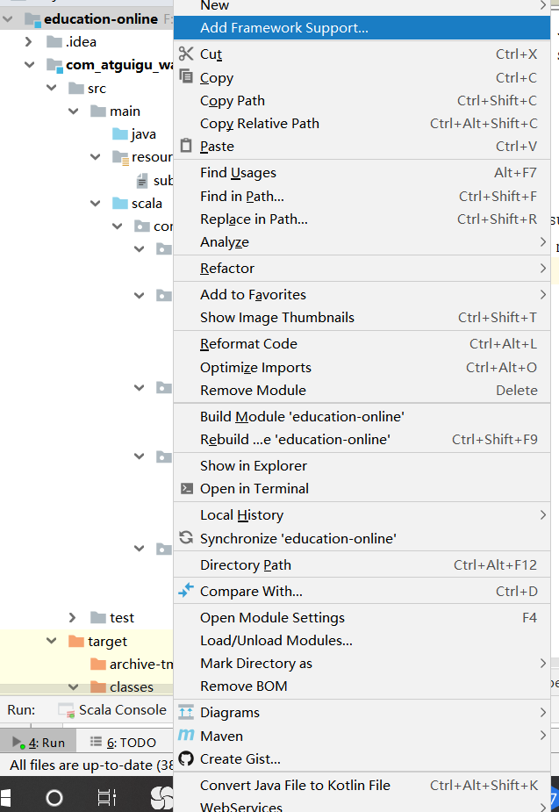

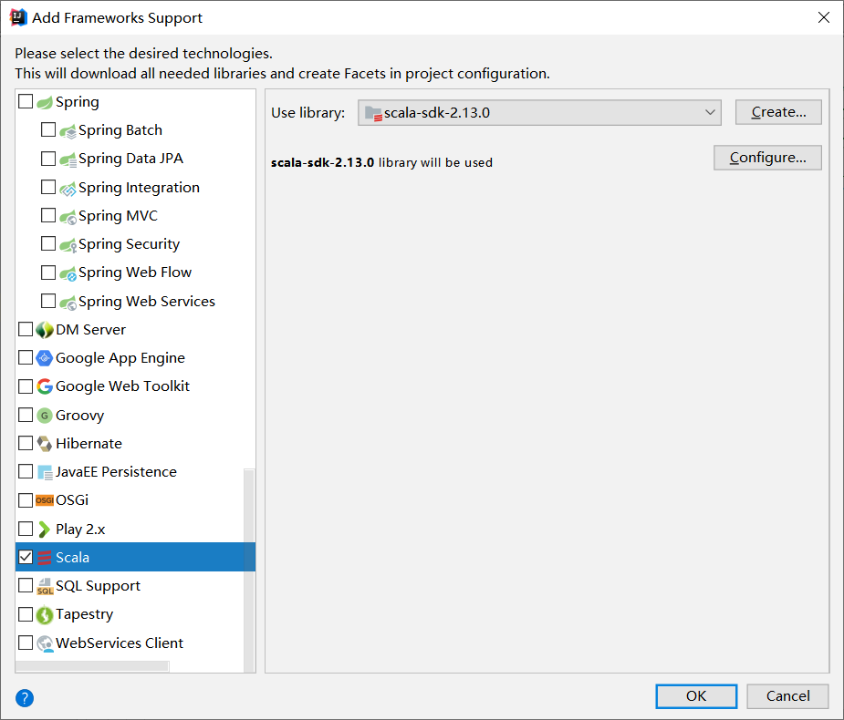

Bean 目录下存放实体类

Controller 目录下存放程序入口类

Dao 目录下存放各表sql类

Service 目录下存放各表业务类

Util目录下存放工具类

# 数据清洗

## 7.1整体类结构

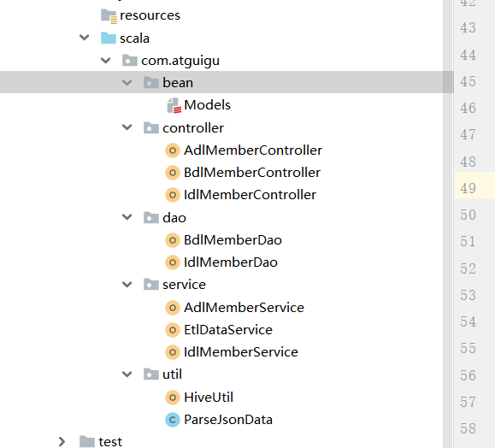

## 7.2创建工具类

解析json使用fastjson,在util下创建ParseJosnData工具类

**package** com.atguigu.util;  
  
**import** com.alibaba.fastjson.JSONObject;  
  
  
**public class** ParseJsonData {  
  
 **public static** JSONObject getJsonData(String data) {  
 **try** {  
 **return** JSONObject.*parseObject*(data);  
 } **catch** (Exception e) {  
 **return null**;  
 }  
 }  
}

在util包下创建Hive工具HiveUtil类

**package** com.atguigu.util  
  
**import** org.apache.spark.sql.SparkSession  
  
**object** HiveUtil {  
  
 */**  
 * 调大最大分区个数  
 \** **@param spark** *\** **@return** *\*/* **def** setMaxpartitions(spark: SparkSession)={  
 spark.sql(**"set hive.exec.dynamic.partition=true"**)  
 spark.sql(**"set hive.exec.dynamic.partition.mode=nonstrict"**)  
 spark.sql(**"set hive.exec.max.dynamic.partitions=100000"**)  
 spark.sql(**"set hive.exec.max.dynamic.partitions.pernode=100000"**)  
 spark.sql(**"set hive.exec.max.created.files=100000"**)  
 }  
 */**  
 * 开启压缩  
 *  
 \** **@param spark** *\** **@return** *\*/* **def** openCompression(spark: SparkSession) = {  
 spark.sql(**"set mapred.output.compress=true"**)  
 spark.sql(**"set hive.exec.compress.output=true"**)  
 }  
  
 */**  
 * 开启动态分区，非严格模式  
 *  
 \** **@param spark** *\*/* **def** openDynamicPartition(spark: SparkSession) = {  
 spark.sql(**"set hive.exec.dynamic.partition=true"**)  
 spark.sql(**"set hive.exec.dynamic.partition.mode=nonstrict"**)  
 }  
  
 */**  
 * 使用lzo压缩  
 *  
 \** **@param spark** *\*/* **def** useLzoCompression(spark: SparkSession) = {  
 spark.sql(**"set io.compression.codec.lzo.class=com.hadoop.compression.lzo.LzoCodec"**)  
 spark.sql(**"set mapred.output.compression.codec=com.hadoop.compression.lzo.LzopCodec"**)  
 }  
  
 */**  
 * 使用snappy压缩  
 \** **@param spark** *\*/* **def** useSnappyCompression(spark:SparkSession)={  
 spark.sql(**"set mapreduce.map.output.compress.codec=org.apache.hadoop.io.compress.SnappyCodec"**);  
 spark.sql(**"set mapreduce.output.fileoutputformat.compress=true"**)  
 spark.sql(**"set mapreduce.output.fileoutputformat.compress.codec=org.apache.hadoop.io.compress.SnappyCodec"**)  
 }  
  
}

## 7.3对日志进行数据清洗导入

收集日志原始数据后 我们需要对日志原始数据进行清洗 将清洗后的数据存入bdl层表

创建EtlDatService清洗类,使用该类读取hdfs上的原始日志数据，对原始日志进行清洗处理，对敏感字段姓名、电话做脱敏处理。filter对不能正常转换json数据的日志数据进行过滤，mappartiton针对每个分区去做数据循环map操作组装成对应表需要的字段,重组完之后coalesce缩小分区（减少文件个数）刷新到目标表中。

**package** com.atguigu.service  
  
**import** java.time.LocalDate  
**import** java.time.format.DateTimeFormatter  
  
**import** com.alibaba.fastjson.JSONObject  
**import** com.atguigu.util.ParseJsonData  
**import** org.apache.spark.SparkContext  
**import** org.apache.spark.sql.{SaveMode, SparkSession}  
  
**object** EtlDataService {  
 */**  
 * etl用户注册信息  
 *  
 \** **@param ssc** *\** **@param sparkSession** *\*/* **def** etlMemberRegtypeLog(ssc: SparkContext, sparkSession: SparkSession) = {  
 **import** sparkSession.implicits._ *//隐式转换* ssc.textFile(**"/user/atguigu/odl/memberRegtype.log"**).filter(item => {  
 **val** obj = ParseJsonData.*getJsonData*(item)  
 obj.isInstanceOf[JSONObject]  
 }).mapPartitions(partitoin => {  
 partitoin.map(item => {  
 **val** jsonObject = ParseJsonData.*getJsonData*(item)  
 **val** appkey = jsonObject.getString(**"appkey"**)  
 **val** appregurl = jsonObject.getString(**"appregurl"**)  
 **val** bdp_uuid = jsonObject.getString(**"bdp_uuid"**)  
 **val** createtime = jsonObject.getString(**"createtime"**)  
 **val** website = jsonObject.getString(**"dn"**)  
 **val** domain = jsonObject.getString(**"webA"**)  
 **val** isranreg = jsonObject.getString(**"isranreg"**)  
 **val** regsource = jsonObject.getString(**"regsource"**)  
 **val** regsourceName = regsource **match** {  
 **case "1"** => **"PC"  
 case "2"** => **"Mobile"  
 case "3"** => **"App"  
 case "4"** => **"WeChat"  
 case** _ => **"other"** }  
 **val** uid = jsonObject.getIntValue(**"uid"**)  
 **val** time = DateTimeFormatter.*ofPattern*(**"yyyyMMdd"**).format(LocalDate.*now*())  
 **val** websiteid = jsonObject.getIntValue(**"websiteid"**)  
 (uid, appkey, appregurl, bdp_uuid, createtime, domain, isranreg, regsource, regsourceName, websiteid, time, website)  
 })  
 }).toDF().coalesce(1).write.mode(SaveMode.*Append*).insertInto(**"bdl.bdl_member_regtype"**)  
 }  
  
 */**  
 * etl用户表数据  
 *  
 \** **@param ssc** *\** **@param sparkSession** *\*/* **def** etlMemberLog(ssc: SparkContext, sparkSession: SparkSession) = {  
 **import** sparkSession.implicits._ *//隐式转换* ssc.textFile(**"/user/atguigu/odl/Member.log"**).filter(item => {  
 **val** obj = ParseJsonData.*getJsonData*(item)  
 obj.isInstanceOf[JSONObject]  
 }).mapPartitions(partition => {  
 partition.map(item => {  
 **val** jsonObject = ParseJsonData.*getJsonData*(item)  
 **val** ad_id = jsonObject.getIntValue(**"ad_id"**)  
 **val** birthday = jsonObject.getString(**"birthday"**)  
 **val** website = jsonObject.getString(**"dn"**)  
 **val** email = jsonObject.getString(**"email"**)  
 **val** fullname = jsonObject.getString(**"fullname"**).substring(0, 1) + **"xx"  
 val** iconurl = jsonObject.getString(**"iconurl"**)  
 **val** lastlogin = jsonObject.getString(**"lastlogin"**)  
 **val** mailaddr = jsonObject.getString(**"mailaddr"**)  
 **val** memberlevel = jsonObject.getString(**"memberlevel"**)  
 **val** password = **"******"  
 val** paymoney = jsonObject.getString(**"paymoney"**)  
 **val** phone = jsonObject.getString(**"phone"**)  
 **val** newphone = phone.substring(0, 3) + **"*****"** + phone.substring(7, 11)  
 **val** qq = jsonObject.getString(**"qq"**)  
 **val** register = jsonObject.getString(**"register"**)  
 **val** regupdatetime = jsonObject.getString(**"regupdatetime"**)  
 **val** uid = jsonObject.getIntValue(**"uid"**)  
 **val** unitname = jsonObject.getString(**"unitname"**)  
 **val** userip = jsonObject.getString(**"userip"**)  
 **val** zipcode = jsonObject.getString(**"zipcode"**)  
 **val** dtf = DateTimeFormatter.*ofPattern*(**"yyyyMMdd"**)  
 **val** time = dtf.format(LocalDate.*now*())  
 (uid, ad_id, birthday, email, fullname, iconurl, lastlogin, mailaddr, memberlevel, password, paymoney, newphone, qq,  
 register, regupdatetime, unitname, userip, zipcode, time, website)  
 })  
 }).toDF().coalesce(2).write.mode(SaveMode.*Append*).insertInto(**"bdl.bdl_member"**)  
 }  
  
 */**  
 * 导入广告表基础数据  
 *  
 \** **@param ssc** *\** **@param sparkSession** *\*/* **def** etlBaseAdLog(ssc: SparkContext, sparkSession: SparkSession) = {  
 **import** sparkSession.implicits._ *//隐式转换* ssc.textFile(**"/user/atguigu/odl/baseadlog.log"**).filter(item => {  
 **val** obj = ParseJsonData.*getJsonData*(item)  
 obj.isInstanceOf[JSONObject]  
 }).mapPartitions(partition => {  
 partition.map(item => {  
 **val** jsonObject = ParseJsonData.*getJsonData*(item)  
 **val** adid = jsonObject.getIntValue(**"adid"**)  
 **val** adname = jsonObject.getString(**"adname"**)  
 **val** website = jsonObject.getString(**"dn"**)  
 (adid, adname, website)  
 })  
 }).toDF().coalesce(1).write.mode(SaveMode.*Overwrite*).insertInto(**"bdl.bdl_base_ad"**)  
 }  
  
 */**  
 * 导入网站表基础数据  
 *  
 \** **@param ssc** *\** **@param sparkSession** *\*/* **def** etlBaseWebSiteLog(ssc: SparkContext, sparkSession: SparkSession) = {  
 **import** sparkSession.implicits._ *//隐式转换* ssc.textFile(**"/user/atguigu/odl/baswewebsite.log"**).filter(item => {  
 **val** obj = ParseJsonData.*getJsonData*(item)  
 obj.isInstanceOf[JSONObject]  
 }).mapPartitions(partition => {  
 partition.map(item => {  
 **val** jsonObject = ParseJsonData.*getJsonData*(item)  
 **val** siteid = jsonObject.getIntValue(**"siteid"**)  
 **val** sitename = jsonObject.getString(**"sitename"**)  
 **val** siteurl = jsonObject.getString(**"siteurl"**)  
 **val** delete = jsonObject.getIntValue(**"delete"**)  
 **val** createtime = jsonObject.getString(**"createtime"**)  
 **val** creator = jsonObject.getString(**"creator"**)  
 **val** website = jsonObject.getString(**"dn"**)  
 (siteid, sitename, siteurl, delete, createtime, creator, website)  
 })  
 }).toDF().coalesce(1).write.mode(SaveMode.*Overwrite*).insertInto(**"bdl.bdl_base_website"**)  
 }  
  
 */**  
 * 导入微信绑定数据  
 *  
 \** **@param ssc** *\** **@param sparkSession** *\*/* **def** etlMemberWxboundLog(ssc: SparkContext, sparkSession: SparkSession) = {  
 **import** sparkSession.implicits._ *//隐式转换* ssc.textFile(**"/user/atguigu/odl/memberwxbound.log"**).filter(item => {  
 **val** obj = ParseJsonData.*getJsonData*(item)  
 obj.isInstanceOf[JSONObject]  
 }).mapPartitions(partition => {  
 partition.map(item => {  
 **val** jSONObject = ParseJsonData.*getJsonData*(item)  
 **val** bindsource = jSONObject.getIntValue(**"bindsource"**)  
 **val** boundtime = jSONObject.getString(**"boundtime"**)  
 **val** website = jSONObject.getString(**"dn"**)  
 **val** headimgurl = jSONObject.getString(**"headimgurl"**)  
 **val** isdefault = jSONObject.getString(**"isdefault"**)  
 **val** nickname = jSONObject.getString(**"nickname"**)  
 **val** openid = jSONObject.getString(**"openid"**)  
 **val** uid = jSONObject.getIntValue(**"uid"**)  
 **val** unionid = jSONObject.getString(**"unionid"**)  
 **val** time = DateTimeFormatter.*ofPattern*(**"yyyyMMdd"**).format(LocalDate.*now*())  
 (uid, unionid, openid, nickname, isdefault, headimgurl, boundtime, bindsource, time, website)  
 })  
 }).toDF().coalesce(1).write.mode(SaveMode.*Append*).insertInto(**"bdl.bdl_member_wxbound"**)  
 }  
  
 */**  
 * 导入微信公众号基础数据  
 *  
 \** **@param ssc** *\** **@param sparkSession** *\*/* **def** etlWxTypeLog(ssc: SparkContext, sparkSession: SparkSession) = {  
 **import** sparkSession.implicits._ *//隐式转换* ssc.textFile(**"/user/atguigu/odl/WxType.log"**).filter(item => {  
 **val** obj = ParseJsonData.*getJsonData*(item)  
 obj.isInstanceOf[JSONObject]  
 }).mapPartitions(partition => {  
 partition.map(item => {  
 **val** jSONObject = ParseJsonData.*getJsonData*(item)  
 **val** app_id = jSONObject.getString(**"app_id"**)  
 **val** bind_source = jSONObject.getIntValue(**"bind_source"**)  
 **val** createtime = jSONObject.getString(**"createtime"**)  
 **val** createtor = jSONObject.getString(**"atguigu"**)  
 **val** website = jSONObject.getString(**"dn"**)  
 **val** token_secret = jSONObject.getString(**"token_secret"**)  
 **val** wx_name = jSONObject.getString(**"wx_name"**)  
 **val** wx_no = jSONObject.getString(**"wx_no"**)  
 (bind_source, app_id, token_secret, wx_name, wx_no, createtor, createtime, website)  
 })  
 }).toDF().coalesce(1).write.mode(SaveMode.*Overwrite*).insertInto(**"bdl.bdl_wxtype"**)  
 }  
  
 */**  
 * 导入用户付款信息  
 *  
 \** **@param ssc** *\** **@param sparkSession** *\*/* **def** etlMemPayMoneyLog(ssc: SparkContext, sparkSession: SparkSession) = {  
 **import** sparkSession.implicits._ *//隐式转换* ssc.textFile(**"/user/atguigu/odl/pcentermempaymoney.log"**).filter(item => {  
 **val** obj = ParseJsonData.*getJsonData*(item)  
 obj.isInstanceOf[JSONObject]  
 }).mapPartitions(partition => {  
 partition.map(item => {  
 **val** jSONObject = ParseJsonData.*getJsonData*(item)  
 **val** website = jSONObject.getString(**"dn"**)  
 **val** paymoney = jSONObject.getString(**"paymoney"**)  
 **val** uid = jSONObject.getIntValue(**"uid"**)  
 **val** vip_id = jSONObject.getIntValue(**"vip_id"**)  
 **val** site_id = jSONObject.getIntValue(**"siteid"**)  
 **val** time = DateTimeFormatter.*ofPattern*(**"yyyyMMdd"**).format(LocalDate.*now*())  
 (uid, paymoney, site_id, vip_id, time, website)  
 })  
 }).toDF().coalesce(1).write.mode(SaveMode.*Append*).insertInto(**"bdl.bdl_pcentermempaymoney"**)  
 }  
  
 */**  
 * 导入用户vip基础数据  
 \** **@param ssc** *\** **@param sparkSession** *\*/* **def** etlMemVipLevelLog(ssc: SparkContext, sparkSession: SparkSession) = {  
 **import** sparkSession.implicits._ *//隐式转换* ssc.textFile(**"/user/atguigu/odl/PcenterMemViplevel.log"**).filter(item => {  
 **val** obj = ParseJsonData.*getJsonData*(item)  
 obj.isInstanceOf[JSONObject]  
 }).mapPartitions(partition => {  
 partition.map(item => {  
 **val** jSONObject = ParseJsonData.*getJsonData*(item)  
 **val** discountval = jSONObject.getString(**"discountval"**)  
 **val** website = jSONObject.getString(**"dn"**)  
 **val** end_time = jSONObject.getString(**"end_time"**)  
 **val** last_modify_time = jSONObject.getString(**"last_modify_time"**)  
 **val** max_free = jSONObject.getString(**"max_free"**)  
 **val** min_free = jSONObject.getString(**"min_free"**)  
 **val** next_level = jSONObject.getString(**"next_level"**)  
 **val** operator = jSONObject.getString(**"operator"**)  
 **val** start_time = jSONObject.getString(**"start_time"**)  
 **val** vip_id = jSONObject.getIntValue(**"vip_id"**)  
 **val** vip_level = jSONObject.getString(**"vip_level"**)  
 (vip_id, vip_level, start_time, end_time, last_modify_time, max_free, min_free, next_level, operator, website)  
 })  
 }).toDF().coalesce(1).write.mode(SaveMode.*Overwrite*).insertInto(**"bdl.bdl_vip_level"**)  
 }  
}

## 7.4创建BdlMemberController

写完具体业务代码后，创建入口类，此类为生产环境spark-shell命令执行所用

**package** com.atguigu.controller  
  
**import** com.atguigu.service.EtlDataService  
**import** com.atguigu.util.HiveUtil  
**import** org.apache.spark.SparkConf  
**import** org.apache.spark.sql.SparkSession  
  
  
**object** BdlMemberController {  
 **def** main(args: Array[String]): Unit = {  
 **val** sparkConf = **new** SparkConf().setAppName(**"bdl_member_import"**)  
 *//.setMaster("local[*]")* **val** sparkSession = SparkSession.*builder*().config(sparkConf).enableHiveSupport().getOrCreate()  
 **val** ssc = sparkSession.sparkContext  
 HiveUtil.*openDynamicPartition*(sparkSession) *//开启动态分区* HiveUtil.*openCompression*(sparkSession) *//开启压缩* HiveUtil.*useSnappyCompression*(sparkSession) *//使用snappy压缩  
 //对用户原始数据进行数据清洗 存入bdl层表中* EtlDataService.*etlBaseAdLog*(ssc, sparkSession) *//导入基础广告表数据* EtlDataService.*etlBaseWebSiteLog*(ssc, sparkSession) *//导入基础网站表数据* EtlDataService.*etlMemberLog*(ssc, sparkSession) *//清洗用户数据* EtlDataService.*etlMemberRegtypeLog*(ssc, sparkSession) *//清洗用户注册数据* EtlDataService.*etlMemberWxboundLog*(ssc, sparkSession) *//导入微信绑定数据* EtlDataService.*etlMemPayMoneyLog*(ssc, sparkSession) *//导入用户支付情况记录* EtlDataService.*etlMemVipLevelLog*(ssc, sparkSession) *//导入vip基础数据* EtlDataService.*etlWxTypeLog*(ssc, sparkSession) *//导入微信基础数据* }  
}

## 7.5 append和overwrite的区别

append 模式在原有分区上进行追加数据操作,overwrite在原有分区上进行全量刷新操作

## 7.6 coalesce和repartion

coalesce和repartiton都用于改变分区，coalesce用于缩小分区且不会进行shuffle，repartion用于增大分区（提供并行度）会进行shuffle,在spark中减少文件个数会使用coalesce来减少分区来到这个目的，但是如果数据量过大，分区数过少会出现OOM所以coalesce缩小分区个数也需合理

# 第8章 创建相应的实体类

在bean目录下创建Models类，用于创建DataSet所需的实体类

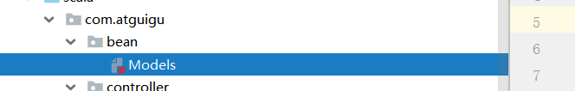

**package** com.atguigu.bean

拉链表所对应实体  
**case class** MemberZipper(  
 uid: Int,  
 paymoney: String,  
 vip_level: String,  
 start_time: String,  
 **var** end_time: String,  
 website: String  
 )  
  
代码groupbykey聚合后根据key聚合后的结果对象

**case class** MemberZipperResult(list: List[MemberZipper])  
  
报表统计层用于查询宽表的实体类  
**case class** QueryResult(  
 uid: Int,  
 ad_id: Int,  
 memberlevel: String,  
 register: String,  
 appregurl: String, *//注册来源url* regsource: String,  
 regsourcename: String,  
 adname: String,  
 siteid: String,  
 sitename: String,  
 vip_level: String,  
 paymoney: BigDecimal,  
 website: String  
 )  
宽表所对应的实体类  
**case class** IdlMember(  
 uid: Int,  
 ad_id: Int,  
 fullname: String,  
 iconurl: String,  
 lastlogin: String,  
 mailaddr: String,  
 memberlevel: String,  
 password: String,  
 paymoney: BigDecimal,  
 phone: String,  
 qq: String,  
 register: String,  
 regupdatetime: String,  
 unitname: String,  
 userip: String,  
 zipcode: String,  
 time: String,  
 appkey: String,  
 appregurl: String,  
 bdp_uuid: String,  
 reg_createtime: String,  
 domain: String,  
 isranreg: String,  
 regsource: String,  
 regsourcename: String,  
 adname: String,  
 siteid: String,  
 sitename: String,  
 siteurl: String,  
 site_delete: String,  
 site_createtime: String,  
 site_creator: String,  
 vip_id: String,  
 vip_level: String,  
 vip_start_time: String,  
 vip_end_time: String,  
 vip_last_modify_time: String,  
 vip_max_free: String,  
 vip_min_free: String,  
 vip_next_level: String,  
 vip_operator: String,  
 website: String  
 )  
  
宽表所对应的实体类  
**case class** IdlMember_Result(  
 uid: Int,  
 ad_id: Int,  
 fullname: String,  
 icounurl: String,  
 lastlogin: String,  
 mailaddr: String,  
 memberlevel: String,  
 password: String,  
 paymoney: String,  
 phone: String,  
 qq: String,  
 register: String,  
 regupdatetime: String,  
 unitname: String,  
 userip: String,  
 zipcode: String,  
 time: String,  
 appkey: String,  
 appregurl: String,  
 bdp_uuid: String,  
 reg_createtime: String,  
 domain: String,  
 isranreg: String,  
 regsource: String,  
 regsourcename: String,  
 adname: String,  
 siteid: String,  
 sitename: String,  
 siteurl: String,  
 site_delete: String,  
 site_createtime: String,  
 site_creator: String,  
 vip_id: String,  
 vip_level: String,  
 vip_start_time: String,  
 vip_end_time: String,  
 vip_last_modify_time: String,  
 vip_max_free: String,  
 vip_min_free: String,  
 vip_next_level: String,  
 vip_operator: String,  
 website: String  
 )

# 第9章 宽表、拉链表

## 9.1创建IdlMemberService业务类

service包下创建IdlMemberService类

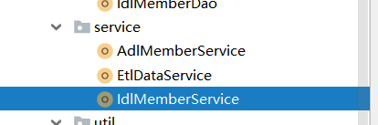

数据清洗完后，需要对清洗后的数据进行合并生产宽表，并同时将历史数据更新到拉链表

## 9.2 使用sql实现宽表

首先查询宽表所需字段，宽表所要用到的表有 bdl.bdl_member，

bdl.bdl_member_regtype，bdl.bdl_base_ad，bdl.bdl_base_website，

bdl.bdl_pcentermempaymoney，bdl.bdl_vip_level。分别重命名为a,b,c,d,e,f。宽表主表为bdl.bdl_member 所以使用用户表left join其他表保证用户数据不会因为join而丢失，因为一个用户存在多条支付金额数据，所以我们需要对用户进行去重处理且是同一个网站分区下的，所以join完之后需要进行group by uid,website操作。然后各字段对于不变的字段我们取第一条数据即可，调用first函数，对于金额字段进行求和使用sum函数，对于开始时间需要取最早的那个值使用min函数，结束时间使用max函数

**def** importMember(sparkSession: SparkSession, time: String) = {  
 **import** sparkSession.implicits._ *//隐式转换  
 //查询全量数据 刷新到宽表* sparkSession.sql(**"select uid,first(ad_id),first(fullname),first(iconurl),first(lastlogin),"** +  
 **"first(mailaddr),first(memberlevel),first(password),sum(cast(paymoney as decimal(10,4))),first(phone),first(qq),"** +  
 **"first(register),first(regupdatetime),first(unitname),first(userip),first(zipcode),"** +  
 **"first(time),first(appkey),first(appregurl),first(bdp_uuid),first(reg_createtime),first(domain),"** +  
 **"first(isranreg),first(regsource),first(regsourcename),first(adname),first(siteid),first(sitename),"** +  
 **"first(siteurl),first(site_delete),first(site_createtime),first(site_creator),first(vip_id),max(vip_level),"** +  
 **"min(vip_start_time),max(vip_end_time),max(vip_last_modify_time),first(vip_max_free),first(vip_min_free),max(vip_next_level),"** +  
 **"first(vip_operator),website from"** +  
 **"(select a.uid,a.ad_id,a.fullname,a.iconurl,a.lastlogin,a.mailaddr,a.memberlevel,"** +  
 **"a.password,e.paymoney,a.phone,a.qq,a.register,a.regupdatetime,a.unitname,a.userip,"** +  
 **"a.zipcode,a.time,b.appkey,b.appregurl,b.bdp_uuid,b.createtime as reg_createtime,b.domain,b.isranreg,b.regsource,"** +  
 **"b.regsourcename,c.adname,d.siteid,d.sitename,d.siteurl,d.delete as site_delete,d.createtime as site_createtime,"** +  
 **"d.creator as site_creator,f.vip_id,f.vip_level,f.start_time as vip_start_time,f.end_time as vip_end_time,"** +  
 **"f.last_modify_time as vip_last_modify_time,f.max_free as vip_max_free,f.min_free as vip_min_free,"** +  
 **"f.next_level as vip_next_level,f.operator as vip_operator,a.website "** +  
 **"from bdl.bdl_member a left join bdl.bdl_member_regtype b on a.uid=b.uid "** +  
 **"and a.website=b.website left join bdl.bdl_base_ad c on a.ad_id=c.adid and a.website=c.website left join "** +  
 **" bdl.bdl_base_website d on b.websiteid=d.siteid and b.website=d.website left join bdl.bdl_pcentermempaymoney e"** +  
 **" on a.uid=e.uid and a.website=e.website left join bdl.bdl_vip_level f on e.vip_id=f.vip_id and e.website=f.website)r "** +  
 **"group by uid,website"**).coalesce(3).write.mode(SaveMode.*Overwrite*).insertInto(**"idl.idl_member"**)

## 9.3 拉链表

*//查询当天增量数据* **val** dayResult = sparkSession.sql(**s"select a.uid,sum(a.paymoney) as paymoney,max(b.vip_level) as vip_level,"** +  
 **s"from_unixtime(unix_timestamp('$**time**','yyyyMMdd'),'yyyy-MM-dd') as start_time,'9999-12-31' as end_time,first(a.website) as website "** +  
 **" from bdl.bdl_pcentermempaymoney a join "** +  
 **s"bdl.bdl_vip_level b on a.vip_id=b.vip_id and a.website=b.website where a.time='$**time**' group by uid"**).as[MemberZipper]

*//查询历史拉链表数据* **val** historyResult = sparkSession.sql(**"select *from idl.idl_member_zipper"**).as[MemberZipper]  
 *//两份数据根据用户id进行聚合 对end_time进行重新修改* dayResult.union(historyResult).groupByKey(item => item.uid + **"_"** + item.website)  
 .mapGroups { **case** (key, iters) =>  
 **val** keys = key.split(**"_"**)  
 **val** uid = keys(0)  
 **val** website = keys(1)  
 **val** list = iters.toList.sortBy(item => item.start_time) *//对开始时间进行排序* **if** (list.size > 1) {  
 *//如果存在历史数据 需要对历史数据的end_time进行修改  
 //获取历史数据的最后一条数据* **val** oldLastModel = list(list.size - 2)  
 *//获取当前时间最后一条数据* **val** lastModel = list(list.size - 1)  
 oldLastModel.end_time = lastModel.start_time  
 }  
 *MemberZipperResult*(list)  
 }.flatMap(_.list).coalesce(3).write.mode(SaveMode.*Overwrite*).insertInto(**"idl.idl_member_zipper"**) *//重组对象打散 刷新拉链表*}

## 9.4 使用api实现宽表

1. 使用api操作
2. .此方法演示如何使用DataFrame Api 合成宽表，首先BdlMemberDao 查询各基础表信息，简单查询。查询出各基础表信息后使用Api进行join各表join完之后调用select方法取出需要的字段转成DataSet[IdelMember],这个时候DataSet是存在一个用户多个支付金额信息的，所以需要进行去重，使用groupbykey算子自定义key规则根据uid和website来进行聚合数据，聚合完数据数据格式就成了（key,iterable[DataSet[IdelMember],DataSet[IdelMember]......]）这一的数格式的KeyValueGroupedDataset，然后调用mapGroups 解析每一行数据，对key进行split操作获取uid和website,对value迭代器进行转换list操作，然后针对list进行各数据的map处理，paymoney金额字段进行reduce求和操作，开始时间取min最小值，结束时间取最大值max,其余不变值取head第一个值。组成一个宽表所需实体类IdlMember_Result,这步操作如果字段数小于等于22可以直接使用元组，但是我们的宽表大于22个字段所以需要用实体类。

重组完数据后就是一个DataSet[IdlMember_Result]，这样就可以对宽表进行插入操作了。

查询用户表基础信息

**def** getBdlMember(sparkSession: SparkSession) = {  
 sparkSession.sql(**"select uid,ad_id,email,fullname,iconurl,lastlogin,mailaddr,memberlevel,"** +  
 **"password,phone,qq,register,regupdatetime,unitname,userip,zipcode,time,website from bdl.bdl_member"**)  
}

查询用户注册信息  
**def** getBdlMemberRegType(sparkSession: SparkSession) = {  
 sparkSession.sql(**"select uid,appkey,appregurl,bdp_uuid,createtime as reg_createtime,domain,isranreg,"** +  
 **"regsource,regsourcename,websiteid as siteid,website from bdl.bdl_member_regtype "**)  
}

查询基础广告信息  
**def** getBdlBaseAd(sparkSession: SparkSession) = {  
 sparkSession.sql(**"select adid as ad_id,adname,website from bdl.bdl_base_ad"**)  
}

查询基础网站信息  
**def** getBdlBaseWebSite(sparkSession: SparkSession) = {  
 sparkSession.sql(**"select siteid,sitename,siteurl,delete as site_delete,"** +  
 **"createtime as site_createtime,creator as site_creator,website from bdl.bdl_base_website"**)  
}

查询基础vip等级信息  
**def** getBdlVipLevel(sparkSession: SparkSession) = {  
 sparkSession.sql(**"select vip_id,vip_level,start_time as vip_start_time,end_time as vip_end_time,"** +  
 **"last_modify_time as vip_last_modify_time,max_free as vip_max_free,min_free as vip_min_free,"** +  
 **"next_level as vip_next_level,operator as vip_operator,website from bdl.bdl_vip_level"**)  
}

查询用户支付金额明细信息  
**def** getBdlPcentermemPayMoney(sparkSession: SparkSession) = {  
 sparkSession.sql(**"select uid,cast(paymoney as decimal(10,4)) as paymoney,vip_id,website from bdl.bdl_pcentermempaymoney"**)  
}

基于各基础表DataFrame join 并重组成宽表

**def** importMemberUseApi(sparkSession: SparkSession) = {  
 **import** sparkSession.implicits._ *//隐式转换* **val** bdlMember = BdlMemberDao.*getBdlMember*(sparkSession) *//主表用户表* **val** bdlMemberRegtype = BdlMemberDao.*getBdlMemberRegType*(sparkSession)  
 **val** bdlBaseAd = BdlMemberDao.*getBdlBaseAd*(sparkSession)  
 **val** bdlBaseWebsite = BdlMemberDao.*getBdlBaseWebSite*(sparkSession)  
 **val** bdlPcentermemPaymoney = BdlMemberDao.*getBdlPcentermemPayMoney*(sparkSession)  
 **val** bdlVipLevel = BdlMemberDao.*getBdlVipLevel*(sparkSession)  
 **val** result = bdlMember.join(bdlMemberRegtype, *Seq*(**"uid"**, **"website"**), **"left_outer"**)  
 .join(bdlBaseAd, *Seq*(**"ad_id"**, **"website"**), **"left_outer"**)  
 .join(bdlBaseWebsite, *Seq*(**"siteid"**, **"website"**), **"left_outer"**)  
 .join(bdlPcentermemPaymoney, *Seq*(**"uid"**, **"website"**), **"left_outer"**)  
 .join(bdlVipLevel, *Seq*(**"vip_id"**, **"website"**), **"left_outer"**)  
 .select(**"uid"**, **"ad_id"**, **"fullname"**, **"iconurl"**, **"lastlogin"**, **"mailaddr"**, **"memberlevel"**, **"password"** , **"paymoney"**, **"phone"**, **"qq"**, **"register"**, **"regupdatetime"**, **"unitname"**, **"userip"**, **"zipcode"**, **"time"**, **"appkey"** , **"appregurl"**, **"bdp_uuid"**, **"reg_createtime"**, **"domain"**, **"isranreg"**, **"regsource"**, **"regsourcename"**, **"adname"** , **"siteid"**, **"sitename"**, **"siteurl"**, **"site_delete"**, **"site_createtime"**, **"site_creator"**, **"vip_id"**, **"vip_level"**,  
 **"vip_start_time"**, **"vip_end_time"**, **"vip_last_modify_time"**, **"vip_max_free"**, **"vip_min_free"**, **"vip_next_level"** , **"vip_operator"**, **"website"**).as[IdlMember]  
 result.groupByKey(item => item.uid + **"_"** + item.website)  
 .mapGroups { **case** (key, iters) =>  
 **val** keys = key.split(**"_"**)  
 **val** uid = Integer.*parseInt*(keys(0))  
 **val** website = keys(1)  
 **val** idlMembers = iters.toList  
 **val** paymoney = idlMembers.filter(_.paymoney != **null**).map(_.paymoney).reduceOption(_ + _).getOrElse(*BigDecimal*.*apply*(0.00)).doubleValue().toString  
 **val** ad_id = idlMembers.map(_.ad_id).head  
 **val** fullname = idlMembers.map(_.fullname).head  
 **val** icounurl = idlMembers.map(_.iconurl).head  
 **val** lastlogin = idlMembers.map(_.lastlogin).head  
 **val** mailaddr = idlMembers.map(_.mailaddr).head  
 **val** memberlevel = idlMembers.map(_.memberlevel).head  
 **val** password = idlMembers.map(_.password).head  
 **val** phone = idlMembers.map(_.phone).head  
 **val** qq = idlMembers.map(_.qq).head  
 **val** register = idlMembers.map(_.register).head  
 **val** regupdatetime = idlMembers.map(_.regupdatetime).head  
 **val** unitname = idlMembers.map(_.unitname).head  
 **val** userip = idlMembers.map(_.userip).head  
 **val** zipcode = idlMembers.map(_.zipcode).head  
 **val** time = idlMembers.map(_.time).head  
 **val** appkey = idlMembers.map(_.appkey).head  
 **val** appregurl = idlMembers.map(_.appregurl).head  
 **val** bdp_uuid = idlMembers.map(_.bdp_uuid).head  
 **val** reg_createtime = idlMembers.map(_.reg_createtime).head  
 **val** domain = idlMembers.map(_.domain).head  
 **val** isranreg = idlMembers.map(_.isranreg).head  
 **val** regsource = idlMembers.map(_.regsource).head  
 **val** regsourcename = idlMembers.map(_.regsourcename).head  
 **val** adname = idlMembers.map(_.adname).head  
 **val** siteid = idlMembers.map(_.siteid).head  
 **val** sitename = idlMembers.map(_.sitename).head  
 **val** siteurl = idlMembers.map(_.siteurl).head  
 **val** site_delete = idlMembers.map(_.site_delete).head  
 **val** site_createtime = idlMembers.map(_.site_createtime).head  
 **val** site_creator = idlMembers.map(_.site_creator).head  
 **val** vip_id = idlMembers.map(_.vip_id).head  
 **val** vip_level = idlMembers.map(_.vip_level).max  
 **val** vip_start_time = idlMembers.map(_.vip_start_time).min  
 **val** vip_end_time = idlMembers.map(_.vip_end_time).max  
 **val** vip_last_modify_time = idlMembers.map(_.vip_last_modify_time).max  
 **val** vip_max_free = idlMembers.map(_.vip_max_free).head  
 **val** vip_min_free = idlMembers.map(_.vip_min_free).head  
 **val** vip_next_level = idlMembers.map(_.vip_next_level).head  
 **val** vip_operator = idlMembers.map(_.vip_operator).head  
 *IdlMember_Result*(uid, ad_id, fullname, icounurl, lastlogin, mailaddr, memberlevel, password, paymoney,  
 phone, qq, register, regupdatetime, unitname, userip, zipcode, time, appkey, appregurl,  
 bdp_uuid, reg_createtime, domain, isranreg, regsource, regsourcename, adname, siteid,  
 sitename, siteurl, site_delete, site_createtime, site_creator, vip_id, vip_level,  
 vip_start_time, vip_end_time, vip_last_modify_time, vip_max_free, vip_min_free,  
 vip_next_level, vip_operator, website)  
 }.show()  
}

创建入口类IdlMemberController类

**package** com.atguigu.controller  
  
**import** com.atguigu.service.IdlMemberService  
**import** com.atguigu.util.HiveUtil  
**import** org.apache.spark.SparkConf  
**import** org.apache.spark.sql.SparkSession  
  
**object** IdlMemberController {  
  
 **def** main(args: Array[String]): Unit = {  
 **val** sparkConf = **new** SparkConf().setAppName(**"idl_member_import"**)  
 *// .setMaster("local[*]")* **val** sparkSession = SparkSession.*builder*().config(sparkConf).enableHiveSupport().getOrCreate()  
 **val** ssc = sparkSession.sparkContext  
 HiveUtil.*openDynamicPartition*(sparkSession) *//开启动态分区* HiveUtil.*openCompression*(sparkSession) *//开启压缩* HiveUtil.*useSnappyCompression*(sparkSession) *//使用snappy压缩* IdlMemberService.*importMember*(sparkSession, **"20190706"**) *//根据用户信息聚合用户表数据  
 // IdlMemberService.importMemberUseApi(sparkSession)* }  
}

## 9.5 DataFrame join的两种方式

1. DataFrameA.join(DataFrameB,DataFrameA(“字段名”)===DataFrameB(“字段名”))
2. DataFrameA.join(DataFrameB，Seq(“字段名”,“字段名”))

两种方式区别在于 第一种不会去重，第二种会去重。

DataFrame join DataFrameB 默认使用inner join，如果需要改变join方式在join方法中第三个参数指定，left_outer或right_outer

## 9.6 BroadCast join

表与表之间进行join涉及到分区与分区之间的数据传输，会进行shuffle。在大表join小表的时候我们可以用广播join来进行优化避免shuffle，从而提高效率。广播join的实现原理为，将小表查出先聚合到driver端，再由driver广播到每个executor上。

代码实现：

**import** **org.apache.spark.sql.functions.broadcast**

broadcast(spark.table("src")).join(spark.table("records"), "key").show()

广播join小表默认值 10MB

可以通过spark.sql.autoBroadcastJoinThread 参数去设置

并不是所有情况都适合使用broadcast join，当两张表数据量都非常大时如果使用broadcast join,那么从driver端传输到executor端的时间将会非常久，当网络传输时间大于shuffle时间的情况下就没有必要去使用broadcast join了。

# 第10章 报表统计

## 10.1 创建AdlMemberService业务类

有了宽表数据后，我们就可以基于宽表对数据进行统计

创建AdlMemberService报表层业务类

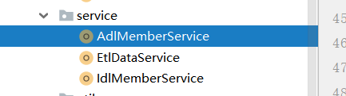

## 10.2 查询报表所需要的基本字段

在dao包下创建IdlMemberDao 此类用于Idl层的表写相应的sql语句,

基于报表所需的宽表字段

创建 queryIdMemberData方法查询报表层所需统计分析的字段

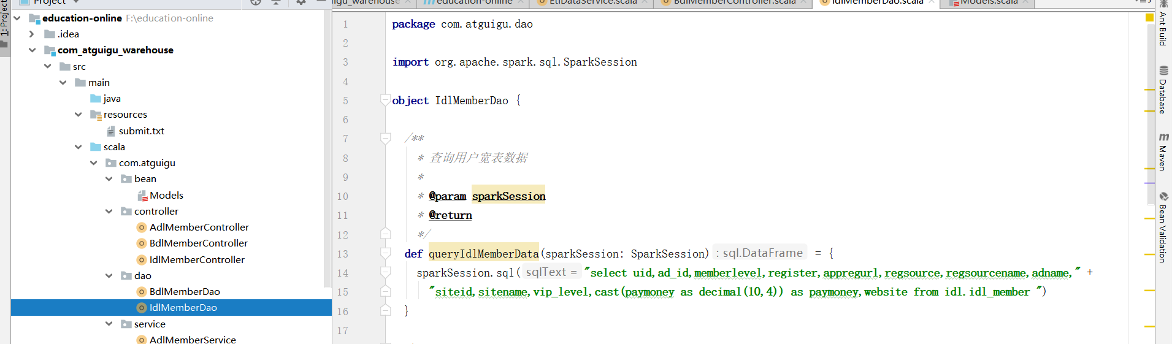

*/**  
 * 查询用户宽表数据  
 *  
 \** **@param sparkSession** *\** **@return** *\*/***def** queryIdlMemberData(sparkSession: SparkSession) = {  
 sparkSession.sql(**"select uid,ad_id,memberlevel,register,appregurl,regsource,regsourcename,adname,"** +  
 **"siteid,sitename,vip_level,cast(paymoney as decimal(10,4)) as paymoney,website from idl.idl_member "**)  
}

## 10.3 使用API统计指标

1. 首先从宽表中查询出报表层需要的字段，转换成DataSet[QueryResult]进行操作，对于统计指标我们需要先将数据进行重组，mapPartitions ->partition.map对每个分区下的数据进行map处理转换成我们需要的数据格式即（需要统计的指标名称+“_”+网站分区，1）的格式，对相同key进行groupbykey聚合操作形成一个

（String,(String,Int)）的一个KeyValueGroupedDataset,对value只需要1不需要key,进行mapVlues操作只取1,然后进行各reduce操作，最后重组成我们需要的数据格式插入到表中。

## 10.4 统计通过各注册跳转地址(appregurl)进行注册的用户数

*/**  
 * 统计各项指标 使用api  
 *  
 \** **@param sparkSession** *\*/***def** queryDetailApi(sparkSession: SparkSession) = {  
 **import** sparkSession.implicits._ *//隐式转换* **val** result = IdlMemberDao.*queryIdlMemberData*(sparkSession).as[QueryResult]  
 result.cache()  
 *//统计注册来源url人数* result.mapPartitions(partition => {  
 partition.map(item => (item.appregurl + **"_"** + item.website, 1))  
 }).groupByKey(_._1).mapValues(item => item._2).reduceGroups(_ + _)  
 .map(item => {  
 **val** keys = item._1.split(**"_"**)  
 **val** appregurl = keys(0)  
 **val** website = keys(1)  
 (appregurl, item._2, website)  
 }).toDF(**"appregurl"**, **"num"**, **"website"**).coalesce(1).write.mode(SaveMode.*Overwrite*).insertInto(**"adl.appregurl_num"**)

## 10.5 统计各所属网站（sitename）的用户数

*//统计所属网站人数* result.mapPartitions(partiton => {  
 partiton.map(item => (item.sitename + **"_"** + item.website, 1))  
 }).groupByKey(_._1).mapValues((item => item._2)).reduceGroups(_ + _)  
 .map(item => {  
 **val** keys = item._1.split(**"_"**)  
 **val** sitename = keys(0)  
 **val** website = keys(1)  
 (sitename, item._2, website)  
 }).toDF(**"sitename"**, **"num"**, **"website"**).coalesce(1).write.mode(SaveMode.*Overwrite*).insertInto(**"adl.sitename_num"**)

## 10.6 统计个所属平台的（regsourcename）的用户数

*////统计所属来源人数 pc mobile wechat app* result.mapPartitions(partition => {  
 partition.map(item => (item.regsourcename + **"_"** + item.website, 1))  
 }).groupByKey(_._1).mapValues(item => item._2).reduceGroups(_ + _)  
 .map(item => {  
 **val** keys = item._1.split(**"_"**)  
 **val** regsourcename = keys(0)  
 **val** website = keys(1)  
 (regsourcename, item._2, website)  
 }).toDF(**"regsourcename"**, **"num"**, **"website"**).coalesce(1).write.mode(SaveMode.*Overwrite*).insertInto(**"adl.regsourcename_num"**)

## 10.7 统计通过各广告跳转（adname）的用户数

*//统计通过各广告进来的人数* result.mapPartitions(partition => {  
 partition.map(item => (item.adname + **"_"** + item.website, 1))  
 }).groupByKey(_._1).mapValues(_._2).reduceGroups(_ + _)  
 .map(item => {  
 **val** keys = item._1.split(**"_"**)  
 **val** adname = keys(0)  
 **val** website = keys(1)  
 (adname, item._2, website)  
 }).toDF(**"adname"**, **"num"**, **"website"**).coalesce(1).write.mode(SaveMode.*Overwrite*).insertInto(**"adl.adname_num"**)

## 10.8 统计各用户基本（memberlevel）的用户数

*//统计各用户等级人数* result.mapPartitions(partition => {  
 partition.map(item => (item.memberlevel + **"_"** + item.website, 1))  
 }).groupByKey(_._1).mapValues(_._2).reduceGroups(_ + _)  
 .map(item => {  
 **val** keys = item._1.split(**"_"**)  
 **val** memberlevel = keys(0)  
 **val** website = keys(1)  
 (memberlevel, item._2, website)  
 }).toDF(**"memberlevel"**, **"num"**, **"website"**).coalesce(1).write.mode(SaveMode.*Overwrite*).insertInto(**"adl.memberlevel_num"**)

## 10.9 统计各vip等级（memberlevel）的用户数

*//统计各vip等级人数* result.mapPartitions(partition => {  
 partition.map(item => (item.vip_level + **"_"** + item.website, 1))  
 }).groupByKey(_._1).mapValues(_._2).reduceGroups(_ + _)  
 .map(item => {  
 **val** keys = item._1.split(**"_"**)  
 **val** vip_level = keys(0)  
 **val** website = keys(1)  
 (vip_level, item._2, website)  
 }).toDF(**"vip_level"**, **"num"**, **"website"**).coalesce(1).write.mode(SaveMode.*Overwrite*).insertInto(**"adl.viplevel_num"**)

## 10.10统计支付金额topN的用户

首先对于查询出来的DataFrame新增一排序列ronum,使用withColumn函数新增，排序规则使用开窗函数，分组字段为website,memberlevel 使用Window.partitionBy算子，分完组之后需要对金额进行倒叙排序所以使用OrderBy(desc(“paymoney”))，再使用这些函数之前需要导包

**import** org.apache.spark.sql.functions._

然后调用Where函数进行过滤只取钱3条数据，对整体数据进行排序orderBy下，最后调用 select函数选出需要的字段对表进场插入操作

*//统计各memberlevel等级 支付金额前三的用户* **import** org.apache.spark.sql.functions._  
 result.withColumn(**"rownum"**, *row_number*().over(Window.*partitionBy*(**"website"**, **"memberlevel"**).orderBy(*desc*(**"paymoney"**))))  
 .where(**"rownum<4"**).orderBy(**"memberlevel"**, **"rownum"**)  
 .select(**"uid"**, **"memberlevel"**, **"register"**, **"appregurl"**, **"regsourcename"**, **"adname"** , **"sitename"**, **"vip_level"**, **"paymoney"**, **"rownum"**, **"website"**)  
 .coalesce(1).write.mode(SaveMode.*Overwrite*).insertInto(**"adl.topmemberpay"**)  
}

## 10.11使用Spark Sql完成各统计指标

在AdlMemberService创建queryDetailSql方法

*/**  
 * 统计各项指标 使用sql  
 *  
 \** **@param sparkSession** *\*/* **def** queryDetailSql(sparkSession: SparkSession) = {  
 **val** appregurlCount = IdlMemberDao.*queryAppregurlCount*(sparkSession)  
 **val** siteNameCount = IdlMemberDao.*querySiteNameCount*(sparkSession).show()  
 **val** regsourceNameCount = IdlMemberDao.*queryRegsourceNameCount*(sparkSession).show()  
 **val** adNameCount = IdlMemberDao.*queryAdNameCount*(sparkSession).show()  
 **val** memberLevelCount = IdlMemberDao.*queryMemberLevelCount*(sparkSession).show()  
 **val** vipLevelCount = IdlMemberDao.*queryMemberLevelCount*(sparkSession).show()  
 **val** top3MemberLevelPayMoneyUser = IdlMemberDao.*getTop3MemberLevelPayMoneyUser*(sparkSession).show()  
 }  
}

在IdlMemberDao类里编写各sql 统计各指标

*/**  
 * 统计注册来源url人数  
 *  
 \** **@param sparkSession** *\*/***def** queryAppregurlCount(sparkSession: SparkSession) = {  
 sparkSession.sql(**"select appregurl,count(uid),website from idl.idl_member group by appregurl,website"**)  
}  
  
*//统计所属网站人数***def** querySiteNameCount(sparkSession: SparkSession) = {  
 sparkSession.sql(**"select sitename,count(uid),website from idl.idl_member group by sitename,website"**)  
}  
  
*//统计所属来源人数***def** queryRegsourceNameCount(sparkSession: SparkSession) = {  
 sparkSession.sql(**"select regsourcename,count(uid),website from idl.idl_member group by regsourcename,website "**)  
}  
  
*//统计通过各广告注册的人数***def** queryAdNameCount(sparkSession: SparkSession) = {  
 sparkSession.sql(**"select adname,count(uid),website from idl.idl_member group by adname,website"**)  
}  
  
*//统计各用户等级人数***def** queryMemberLevelCount(sparkSession: SparkSession) = {  
 sparkSession.sql(**"select memberlevel,count(uid),website from idl.idl_member group by memberlevel,website"**)  
}  
  
*//统计各用户vip等级人数***def** queryVipLevelCount(sparkSession: SparkSession) = {  
 sparkSession.sql(**"select vip_level,count(uid),website from idl.idl_member group by vip_level,website"**)  
}  
  
*//统计各memberlevel等级 支付金额前三的用户***def** getTop3MemberLevelPayMoneyUser(sparkSession: SparkSession) = {  
 sparkSession.sql(**"select *from(select uid,ad_id,memberlevel,register,appregurl,regsource"** +  
 **",regsourcename,adname,siteid,sitename,vip_level,cast(paymoney as decimal(10,4)),row_number() over"** +  
 **" (partition by website,memberlevel order by cast(paymoney as decimal(10,4)) desc) as rownum,website from idl.idl_member) "** +  
 **" where rownum<4 order by memberlevel,rownum"**)  
}

## 10.12创建AdlMemberController入口类

在controller包下创建AdlMemberController入口类，

**package** com.atguigu.controller  
  
**import** com.atguigu.service.AdlMemberService  
**import** com.atguigu.util.HiveUtil  
**import** org.apache.spark.SparkConf  
**import** org.apache.spark.sql.SparkSession  
  
**object** AdlMemberController {  
 **def** main(args: Array[String]): Unit = {  
 **val** sparkConf = **new** SparkConf().setAppName(**"adl_member_controller"**)*//.setMaster("local[*]")* **val** sparkSession = SparkSession.*builder*().config(sparkConf).enableHiveSupport().getOrCreate()  
 **val** ssc = sparkSession.sparkContext  
 HiveUtil.*openDynamicPartition*(sparkSession) *//开启动态分区* HiveUtil.*openCompression*(sparkSession) *//开启压缩* HiveUtil.*useSnappyCompression*(sparkSession) *//使用snappy压缩* AdlMemberService.*queryDetailApi*(sparkSession)  
*// AdlMemberService.queryDetailSql(sparkSession)* }  
}

# 第11章 总结

## 11.1 select方法

当业务需求只取DataFrame的某几列时可以使用select方法来获取其中几列

DataFrame.select(“字段1”,“字段2”,“字段3”) 方法返回值为Dataframe

## 11.2 drop方法

DataFrame.drop(“colname”) 删除dataframe总的某列

## 11.3 withColum方法

当需要对DataFrame新增列时可以使用withColum方法

DataFrame.withColumn(“新增列名”,Column) 第二个参数为列，需要使用表达式

如果需要新增一个固定值的列比如 在result DataFrame上新增姓名 “张三”

result.withColumn(“name”,lit(“张三”) 可以使用lit方法在增加固定值

如果需要新增像排序列类似的那么就需要编写相应的函数

## 11.4排序与窗口函数

比如在上述的需求中需要新增一列排序列

**import** org.apache.spark.sql.functions._

result.withColumn(**"rownum"**, *row_number*().over(Window.*partitionBy*(**"website"**, **"memberlevel"**).orderBy(*desc*(**"paymoney"**))))

需要先导包

**import** org.apache.spark.sql.functions._

才能是用row_number方法，所有在functions类下的方法都需要这部操作

调用窗口函数为

Window.partitionBy() 方法内可以有多个列名，基于这些列去排序

如果对结果需要排序再继续追加Order by方法,方法内可以有多个列名

在Order by 中可以默认asc升序 可以使用desc（“列名”）来进行一个倒叙排序

## 11.5 Cache级别

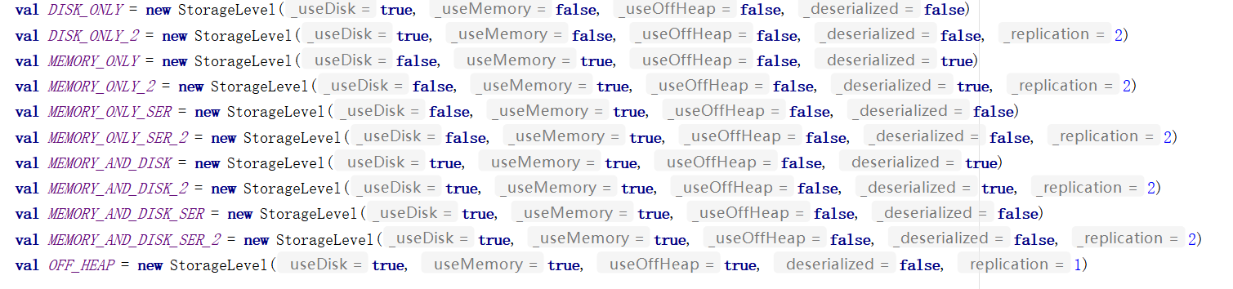

分别是

DISK_ONLY:只缓存到磁盘没有副本

DISK_ONLY_2:只缓存到磁盘有2份副本

MEMORY_ONLY:只缓存到内存没有副本

MEMORY_ONLY_2:只缓存到内存有2份副本

MEMORY_ONLY_SER:只缓存到内存并且序列化没有副本

MEMORY_ONLY_SER_2:只缓存到内存并且序列化有2份副本

MEMORY_AND_DISK:缓存到内存和磁盘没有副本

MEMORY_AND_DISK_2:缓存到内存和磁盘有2份副本

MEMORY_AND_DISK_SER:缓存到内存和磁盘并且序列化

MEMORY_ADN_DISK_SER_2:缓存到内存和磁盘并且序列化有2份副本

OFF_HEAP:缓存到堆外内存

那么DataFrame的cache默认采用 MEMORY_AND_DISK

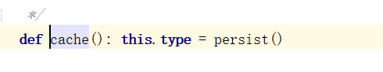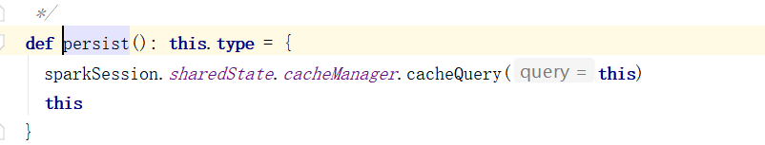

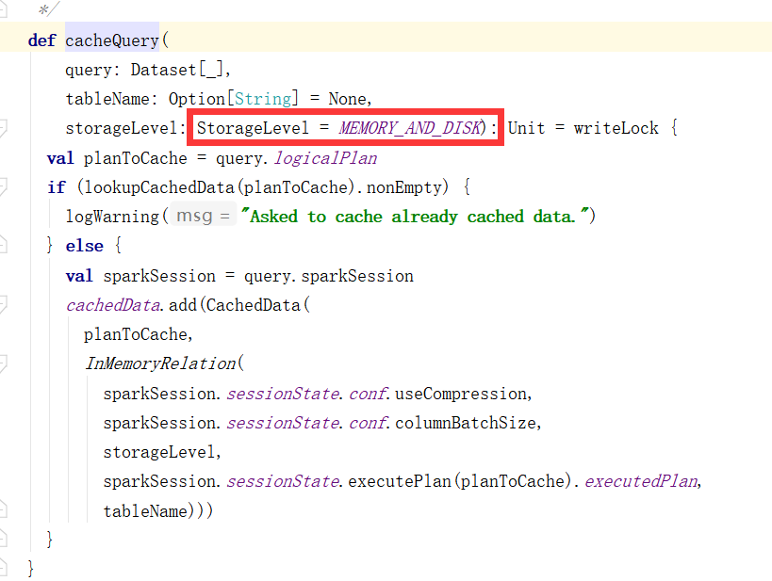

## 11.6 释放缓存与缓存方法

缓存：(1)dataFrame.cache (2)sparkSession.catalog.cacheTable(“tableName”)

释放缓存：(1)dataFrame.unpersist (2)sparkSession.catalog.uncacheTable(“tableName”)

## 11.7 Spark Sql默认并行度

Spark sql默认shuffle并行度为200 可对spark.sql.shuffle.partitions参数进行修改

## 11.8 Kryo序列化

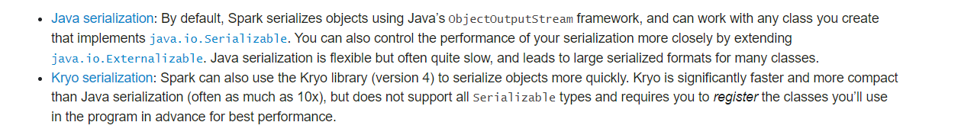

根据官网描述 kryo序列化比java序列化更快更紧凑，但spark默认的序列化是java序列化并不是spark序列化，因为spark并不支持所有序列化类型，而且每次使用都必须进行注册。

那么在使用kryo序列化后再使用序列化缓存能够非常大的减小内存所使用的大小。

所以对内存上的优化我们可以使用kryo来进行优化

但是根据官网描述序列化缓存级别对cpu使用并不友好

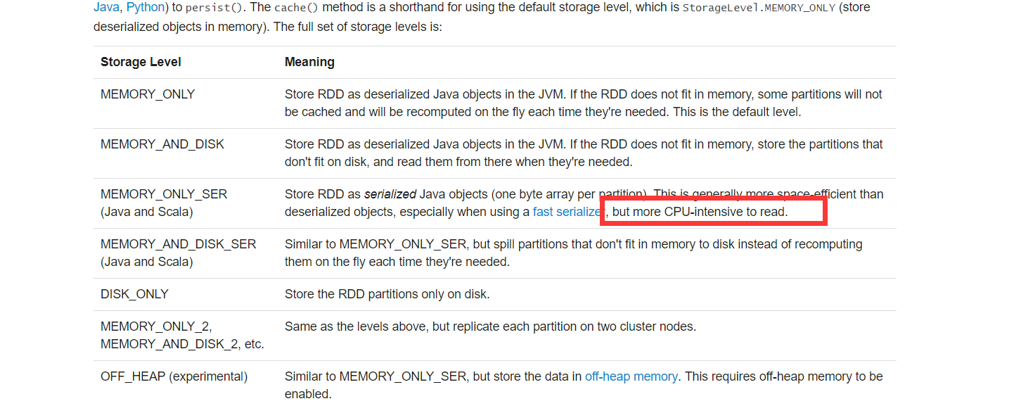

所以什么场景下使用cache，什么场景下使用序列化缓存？

在集群资源绝对充足的情况下推荐直接使用cache

在集群内存资源十分紧张的情况推荐下使用kryo序列化，并使用 persist(StorageLevel.*MEMORY_ONLY_SER*)

如何使用以上述需求为例：

**val** result = IdlMemberDao.*queryIdlMemberData*(sparkSession).as[QueryResult]

result为DataSet[QueryResult]

那么需要对QueryResult进行keyo注册



注册完毕后进行缓存

result.persist(StorageLevel.*MEMORY_ONLY_SER*)

官方例子：

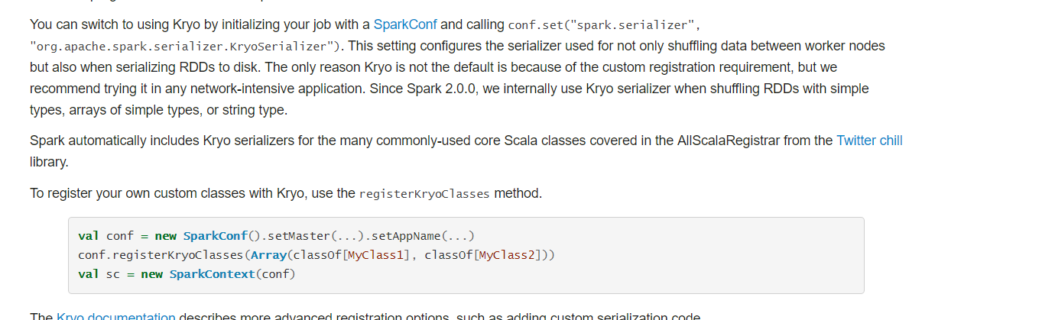

注意：如果不注册kryo序列化，直接使用序列化缓存占用的内存反而会更大

## 11.9 dataframe的groupbykey

dataframe并没有reducebykey算子，只有reduce算子但是reduce算子并不符合业务需求，那么需要使用Spark2.0新增算子groupbykey，groupbykey后返回结果会转换成KeyValueGroupDataSet，开发者可以自定义key，groupbykey后数据集就变成了一个

(key,iterable[bean1,bean2,bean3]) bean为dataset所使用的实体类，groupbykey后，会将所有符合key规则的数据聚合成一个迭代器放在value处，那么如果我们需要对key和value进行重组就可以是用mapGroups算子，针对这一对key,value数据，可以对value集合内的数据进行求和处理重组一个返回对象,mapGroups的返回值是一个DataSeT,那么返回的就是你所重组的DataSet,操作类似于rdd groupbykey map。

如果需要保留key,只需要对value进行重构那么可以调用mapValues方法重构value,再进行reduceGroups对value内的各属性进行汇总.

代码样例：

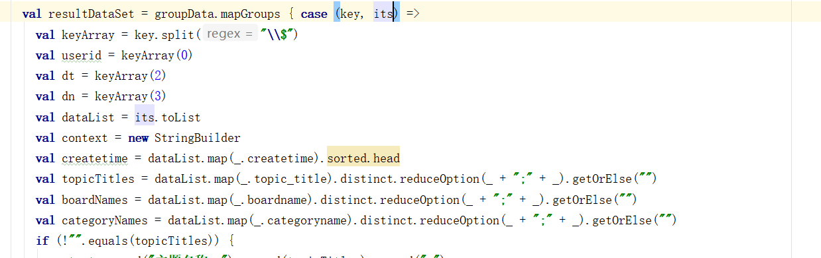

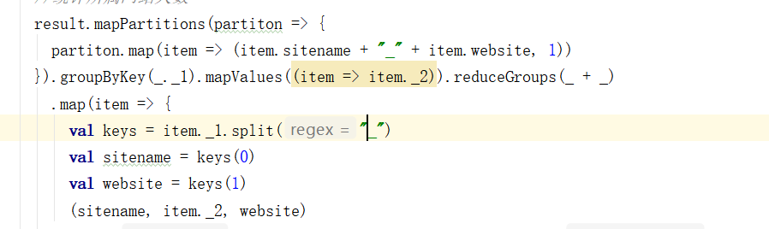

## 11.10 创建临时表和全局临时表

普通临时表只是针对于一个spark session,而全局临时表了引用于所有spark session

创建方法:

DataFrame.createTempView() 创建普通临时表

DataFrame.createGlobalTempView() DataFrame.createOrReplaceTempView() 创建全局临时表

## 11.11注册udf函数

**def** spliceAttr(spark: SparkSession) = {  
 spark.udf.register(**"spliceAttr"**, (v1: String, v2: String) => {  
 **"attr_name:"** + v1 +**" attr_value:"** + v2  
 })  
}

# 第12章 打包、spark-submit命令

对com_atguigu_warhouse打包上传到linux机上

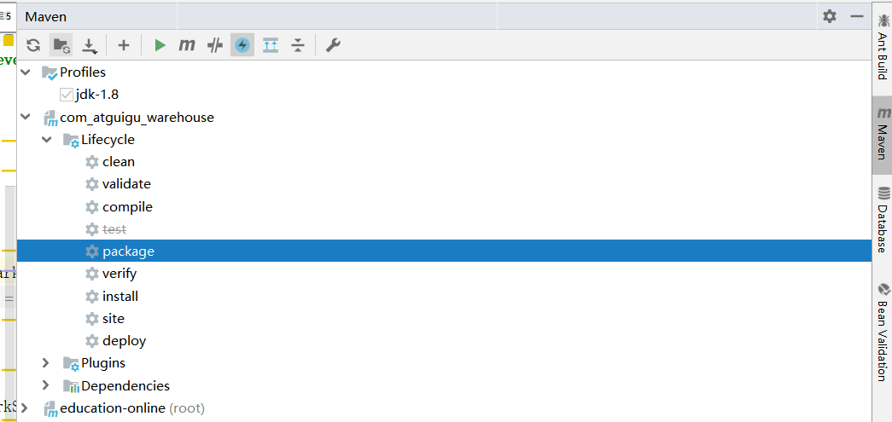

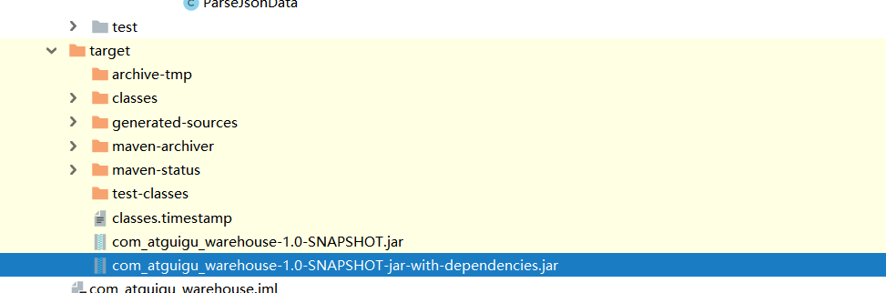

执行相应spark-submit命令

spark-submit --master yarn --deploy-mode client --driver-memory 1g --num-executors 2 --executor-cores 2 --executor-memory 2g

--class com.atguigu.controller.BdlMemberController com_atguigu_warehouse-1.0-SNAPSHOT-jar-with-dependencies.jar

spark-submit --master yarn --deploy-mode client --driver-memory 1g --num-executors 2 --executor-cores 2 --executor-memory 2g

--class com.atguigu.controller.IdlMemberController

com_atguigu_warehouse-1.0-SNAPSHOT-jar-with-dependencies.jar

spark-submit --master yarn --deploy-mode client --driver-memory 1g --num-executors 2 --executor-cores 2 --executor-memory 2g

--class com.atguigu.controller.AdlMemberController

com_atguigu_warehouse-1.0-SNAPSHOT-jar-with-dependencies.jar

# 第13章 本地Intelij idea连接集群环境操作

## 13.1 前提要求

本机环境必须能ping通集群ip地址和端口号

## 13.2 获取hive-site.xml配置文件

从集群上获取到hive-site.xml，将hive-site.xml放到resources源码包下 这样就可以在本地Intelij idea上使用local模式直接进行操作

# 第14章 debug调试

普通的debug调试这就不写了，本地调试的时候如何在海量数据中找出某一条想要的数据进行调试。

操作：

首先打个普通断点，断点位于你想要的调试处

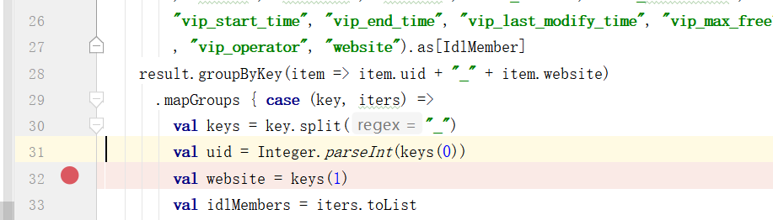

选中断点右键

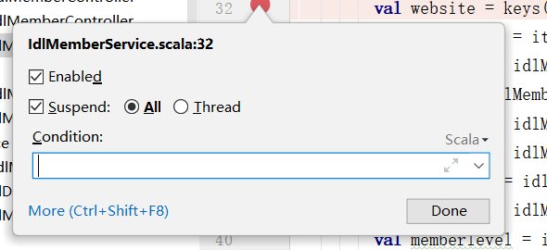在condition处编写条件，比如我想调试uid为1001的用户

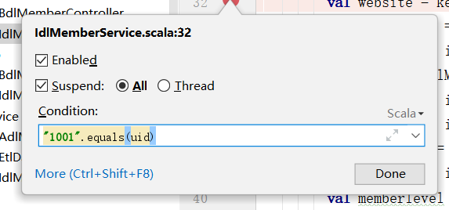编写完毕后点击done 然后启动debug模式运行代码，当uid为10001的数据到达此断点处则进入debug模式，其余数据则会过滤不进入debug模式。

# 第15章 需要注意的点

1. 每次数据重组后 插入表之前需要缩小分区来减小文件个数，使用coalesce 算子（但数据量大 并行度小会造成OOM 所以需要合理缩小并行度） 缩小分区使用coalesce 增大分区使用repartition
2. 使用API写代码时需要注意Spark版本，groupByKey 是Spark2.0新增算子，调用后数据返回结果是KeyValueGroupedDataset。

（3）调用row_number、broadcast 需要导包

**import** org.apache.spark.sql.functions._

但是，这个类的所有方法也只有在Spark2.0后能正常使用，在Spark 1.6中虽然有这个类，但是必须转换成hiveContext,才能使用类里的方法。需要记住广播join（broadcat join）触发的默认值（数据量小于等于10MB）